**Casino & Hospitality Sector**

**FY2023 Financial Statements Analysis**

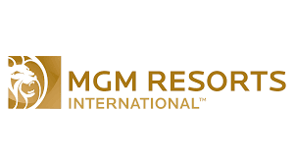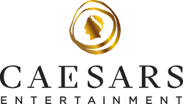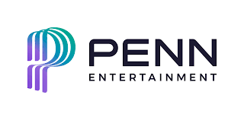

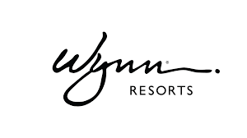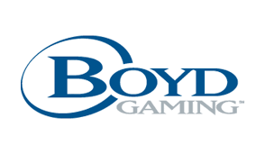



Seiji Hirano

Table of Contents

Report Overview & Background 7

Description 7

Methodology 7

Industry Overview 7

Industry Trend 7

Common Risk Factors 7

Financial Ratio Industry Comparison (2023) 8

Profitability 8

Liquidity 9

Solvency 9

Activity 10

Valuation 10

Key Highlights 11

Key Players Horizontal Analysis 12

MGM Resorts International 12

Employees & Labor Relations 12

Business 12

Key Risk Factors Unique to MGM Resorts International 12

Properties (as of Dec. 31, 2023) 13

Balance Sheet Chart 14

P/L Chart 14

Cash Flow Chart 15

Historical Financial Ratios 15

Long-Term Debt (Most Recent Years) 16

Maturities of Long-Term Debt / Estimated Debt Service Requirements 16

Key Financial Insights 16

Caesars Entertainment 19

Employees & Labor Relations 19

Business 19

Key Risk Factors Unique to Caesars Entertainment 19

Properties (as of Dec. 31, 2023) 20

Balance Sheet Chart 21

P/L Chart 21

Cash Flow Chart 22

Historical Financial Ratios 22

Long-Term Debt (Most Recent Years) 23

Maturities of Long-Term Debt / Estimated Debt Service Requirements 23

Key Financial Insights 23

PENN Entertainment 26

Employees & Labor Relations 26

Business 26

Key Risk Factors Unique to PENN Entertainment 26

Properties (as of Dec. 31, 2023) 27

Balance Sheet Chart 28

P/L Chart 28

Cash Flow Chart 29

Historical Financial Ratios 29

Long-Term Debt (Most Recent Years) 30

Maturities of Long-Term Debt / Estimated Debt Service Requirements 30

Key Financial Insights 30

Wynn Resorts 33

Employees & Labor Relations 33

Business 33

Key Risk Factors Unique to Wynn Resorts 34

Properties (as of Dec. 31, 2023) 34

Balance Sheet Chart 35

P/L Chart 35

Cash Flow Chart 36

Historical Financial Ratios 36

Long-Term Debt (Most Recent Years) 37

Maturities of Long-Term Debt / Estimated Debt Service Requirements 37

Key Financial Insights 37

Boyd Gaming 41

Employees & Labor Relations 41

Business 41

Key Risk Factors Unique to Boyd Gaming 41

Properties (as of Dec. 31, 2023) 42

Balance Sheet Chart 43

P/L Chart 43

Cash Flow Chart 44

Historical Financial Ratios 44

Long-Term Debt (Most Recent Years) 45

Maturities of Long-Term Debt / Estimated Debt Service Requirements 45

Key Financial Insights 46

Red Rock Resorts (Station Casinos) 47

Employees & Labor Relations 47

Business 47

Organizational Structure 48

Key Risk Factors Unique to Red Rock Resorts 49

Properties (as of Dec. 31, 2023) 49

Balance Sheet Chart 50

P/L Chart 50

Cash Flow Chart 51

Historical Financial Ratios 51

Long-Term Debt (Most Recent Years) 52

Maturities of Long-Term Debt / Estimated Debt Service Requirements 52

Key Financial Insights 52

Final Notes 55

Supplemental Data 56

MGM Resorts International 56

Net Revenues & Adjusted EBITDAR by Segment 56

Historical Operating Expenses 56

KPIs by Segment 57

Income from Unconsolidated Affiliates 57

Historical Balance Sheet 58

Historical P/L Statement 58

Historical Equity Statement 59

Historical Cash Flow Statement 61

Caesars Entertainment 62

Net Revenues & Adjusted EBITDAR by Segment 62

Historical Operating Expenses 62

KPIs by Segment 63

Historical Balance Sheet 64

Historical P/L Statement 64

Historical Equity Statement 65

Historical Cash Flow Statement 66

PENN Entertainment 67

Net Revenues & Adjusted EBITDAR by Segment 67

Historical Operating Expenses 67

KPIs 67

Historical Balance Sheet 68

Historical P/L Statement 68

Historical Equity Statement 69

Historical Cash Flow Statement 71

Wynn Resorts 72

Net Revenues & Adjusted EBITDAR by Segment 72

Historical Operating Expenses 72

KPIs by Segment 72

Historical Balance Sheet 74

Historical P/L Statement 74

Historical Equity Statement 75

Historical Cash Flow Statement 76

Boyd Gaming 77

Net Revenues & Adjusted EBITDAR by Segment 77

Historical Operating Expenses 77

Historical Gross Margin % by Segment 77

KPIs by Segment 77

Historical Balance Sheet 78

Historical P/L Statement 78

Historical Equity Statement 79

Historical Cash Flow Statement 81

Red Rock Resorts 82

Net Revenues & Adjusted EBITDA by Segment 82

Historical Operating Expenses 82

Historical Gross Margin % by Segment 82

KPIs by Segment 82

Historical Balance Sheet 83

Historical P/L Statement 83

Historical Equity Statement 84

Historical Cash Flow Statement 86

DuPont Analysis (2023) 86

MGM Resorts International 87

Caesars Entertainment 87

PENN Entertainment 87

Wynn Resorts 87

Boyd Gaming 87

Red Rock Resorts (Station Casinos) 87

Financial Ratios Formula 88

Activity Ratios 88

Liquidity Ratios 89

Solvency Ratios 89

Profitability Ratios 90

Valuation Ratios 90

# Report Overview & Background

## Description

This report is designed to provide a detailed overview of the traditional casino & hospitality industry.

## Methodology

This report solely relies on data from each company’s financial statements.

# Industry Overview

## Industry Trend

* **Online sports-betting and gaming** are a rapidly developing sector. Key players in the industry believe that the digital segment of the global betting and gaming industry will continue to grow.

|  |  |
| --- | --- |
| MGM | BetMGM |
| Caesars | Caesars Sportsbook / Caesars Racebook / iGaming mobile app |
| PENN | ESPN Bet / theScore Bet / iGaming mobile app |
| Wynn | WynnBet |
| Boyd | Online sports-betting under the FanDuel brand / Boyd Sports (LV) /  Online casino gambling under the Stardust brand |
| Red Rock (Station) | STN Sports / STN Play |

* Las Vegas has been experiencing a change in customer preferences due to a variety of factors. For example, demographic changes have resulted in recent growth in customer demand for non-gaming offerings.

## Common Risk Factors

* The industry is sensitive to **economic factors impacting discretionary expenditures***.* Examples include but not limited to:
  + Inflation
  + Perceived/actual general economic conditions
  + Consumer confidence in the economy
  + Energy/water/food costs
  + Interest rates
  + Cost of travel
  + Disposable consumer income
* Companies in the industry usually face **significant financial commitments**, mainly due to rent payments and debt services, which could have negative consequences, including but not limited to:
  + Increased exposure to general economic conditions
  + Limited flexibility in planning for, or reacting to, changes in the markets
  + Limited ability to fund for working capital requirements, CapEx, debt service, etc.

# Financial Ratio Industry Comparison (2023)

Note:

* A more detailed analysis of each company will be performed in the next section.
* The formula for each ratio is described in the supplemental data section.

## Profitability



Quick Insights:

* **Red Rock** and **Boyd** were the top performers in terms of profitability.
* **PENN** was the worst performer in terms of profitability, with the lowest in all margin ratios.
* **PENN** and **MGM** had a significant drop between EBITDAR Margin and EBIT Margin (24.3% down and 20.1% down, respectively), which indicates that they have more leased properties (or depreciation/amortization) than the others. In fact, a table below shows that MGM and PENN had more leased properties as of December 31, 2023.



* **Caesars**, **Wynn,** and **Red Rock** had a significant drop between EBIT Margin and Pre-Tax Margin (20.3% down, 11.5% down, and 10.5% down, respectively), indicating that they have high interest expenses.
* **Red Rock, Boyd** and **MGM** had higher ROE than the others with 2.45, 0.37, and 0.28, respectively.

## Liquidity



Quick Insights:

* **Wynn** and **MGM** had more liquidity than the others, indicating they have a greater ability to meet their short-term liability.
* **Caesars, Boyd,** and **Red Rock** hadliquidity ratios smaller than 1, which indicates that their short-term liabilities exceeded their short-term assets. This suggests a possible inability to meet short-term obligations unless they are confident in their ability to generate cash from operating activities.

## Solvency



Quick Insights:

* **Red Rock** was the most leveraged firms with a financial leverage of 26.44 and debt-to-equity ratio of 13.79. Given that the company has lower liquidity, this significantly higher financial leverage can be concerning. While the company had high profitability and sufficient operating income to cover its interest expenses in 2023, as indicated by its interest coverage ratio of 3.20, it has a much higher risk of financial distress or bankruptcy if it fails to generate sufficient cash flow to meet its debt obligations. The company’s high ROE can be explained by both high profitability and high financial leverage.
* **MGM** was another financially leveraged firm with a debt-to-equity ratio of 7.30. This is favorable in MGM’s case, as the company can easily service its debt obligations through its sufficient cash flow and is using the leverage to increase equity returns. The company’s high financial leverage explains its high ROE as mentioned earlier.
* **Caesars** is also a more leveraged firm with a debt-to-equity of 5.31. However, this can be a red flag as the company appears to have cash flow issues based on its liquidity ratios. Its low interest coverage further indicates cash flow challenges.
* **Wynn**’s high debt-to-capital and debt-to-assets make sense, as the company has negative equity. Its debt-to-equity and interest coverage ratio are not very useful due to the negative equity, but the company is still financially more leveraged.
* **PENN** and **Boyd** are less reliant on debt than their competitors.
* **Boyd** had lower liquidity, as mentioned earlier, but it generates enough operating income and can easily cover its interest expenses, indicating strong solvency.

## Activity



*** PENN does not report inventory; therefore, it is impossible to calculate DIO, DPO, and CCC

Quick Insights:

* **MGM** uses its fixed assets (PP&E) most effectively to generate revenue. For every dollar invested in fixed assets, a return of about 3 dollars is earned. On the other hand, **Red Rock** appears to be the least efficient in utilizing its fixed assets, as indicated by its fixed assets turnover of 0.69.
* **Caesars** had the second lowest fixed assets turnover and the lowest total assets turnover, indicating its overall inefficiency in utilizing assets.
* **PENN** uses its working capital most effectively to generate revenue.
* **Wynn**, **Red Rock**,and **Boyd** utilize their total assets more effectively to generate revenue.
* **MGM**’s higher equity turnover can be explained by its high financial leverage while **Red Rock**’s higher equity turnover can be attributed to both its high profitability and high financial leverage.

## Valuation



## Key Highlights

* **MGM Resorts**
  + Leases all properties from the third party, resulting in high lease expenses.
  + Has high financial leverage but can generate sufficient cash flow to cover its principal and interest payments with balanced liquidity and solvency.
  + Effectively uses its debt to leverage their operations, making their ROE higher than its competitors.
* **Caesars Entertainment**
  + Descent profitability from main business operations (Gross/EBITDAR/EBIT), but high interest expenses lead to a very low pre-tax margin.
  + Low liquidity and high financial leverage, indicating its financial instability.
  + Possible inefficiency in utilizing fixed assets and total assets to generate revenues, suggesting that the company’s higher margins from the core operations may be attributable to lower wages.
* **PENN Entertainment**
  + The lowest profitability among its competitors.
  + Has more leased properties than its competitors, causing a significant drop between EBITDAR margin and EBIT margin.
  + Less reliant on debt but has low interest coverage due to its low profitability.
* **Wynn Resorts**
  + Has negative equity.
  + A significant drop between EBIT Margin and pre-tax Margin, indicating its high interest expenses.
  + Has high financial leverage but also has high liquidity, indicating the ability to meet short-term obligations.
* **Boyd Gaming**
  + The second highest profitability.
  + Has low liquidity but generates a significant amount of cash, easily covering its interest payments.
  + Less reliant on debt.
  + High ROE due to high profitability.
* **Red Rock Resorts**
  + The highest profitability.
  + The highest financial leverage.
  + A significant drop between EBIT margin and pre-tax margin, indicating high interest expenses.

# Key Players Horizontal Analysis



## MGM Resorts International

### Employees & Labor Relations

As of December 31, 2023, the company had approximately 45,000 full-time and 18,000 part-time employees domestically. In addition, the company had approximately 12,000 and 1,000 at MGM China and LeoVegas, respectively. The company had collective bargaining agreements with unions covering approximately 37,000 of its employees as of December 31, 2023.

### Business

As of December 31, 2023, the company operates 16 domestic casino properties.

Additionally, through its 56% controlling interest in MGM China Holdings Limited (together with its subsidiaries, “MGM China”), the company operates two casino properties in Macau.

The company also has global online gaming operations through its consolidated subsidiary LB Lion Holding Limited (“LeoVegas”) and its unconsolidated 50% owned venture, BetMGM, LLC (“BetMGM”).

The company also has a 50% ownership interest in Osaka IR KK, an unconsolidated affiliate, which plans to develop an integrated resort in Osaka, Japan.

In recent years, the company has implemented an **asset-light** business model, which has involved a comprehensive review of its owned real estate assets to find opportunities to monetize those assets efficiently and allow unlocked capital to be redeployed towards balance sheet improvements, new growth opportunities, and to return value to its shareholders. At the same time, the company has continued to focus on key growth opportunities, particularly by investing in U.S. online sports betting and iGaming through BetMGM, acquiring LeoVegas to expand its global online presence, expanding its digital capabilities, and seeking to diversify its Asia operations with development efforts in Japan.

### Key Risk Factors Unique to MGM Resorts International

* **All** its domestic gaming facilities are leased and could experience risks associated with leased property, including risks relating to lease termination, lease extensions, etc., which could have a material adverse effect on its business, financial position, or results of operations.
* Since a significant number of the company’s major gaming resorts are located on the Las Vegas Strip, the company is subject to greater risks than a gaming company that is more geographically diversified.
* Co-investing in properties or businesses, including investment in BetMGM, decreases the company’s ability to manage risk.
* The Macau government can (i) terminate MGM Grand Paradise’s concession under certain circumstances without compensating MGM Grand Paradise, (ii) from the eighth year of MGM Grand Paradise’s concession, redeem the concession by providing MGM Grand Paradise at least one year’s prior notice and subject to the payment of reasonable and fair damages or indemnity to MGM Grand Paradise, or (iii) refuse to grant MGM Grand Paradise an extension of the concession prior to its expiry.
* Conflicts of interest may arise because certain of our directors and officers are also directors of MGM China, the holding company for MGM Grand Paradise which owns and operates MGM Macau and MGM Cotai.

### Properties (as of Dec. 31, 2023)

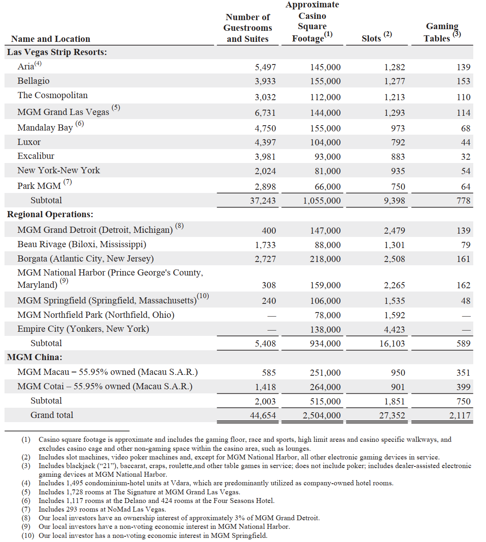

### Balance Sheet Chart

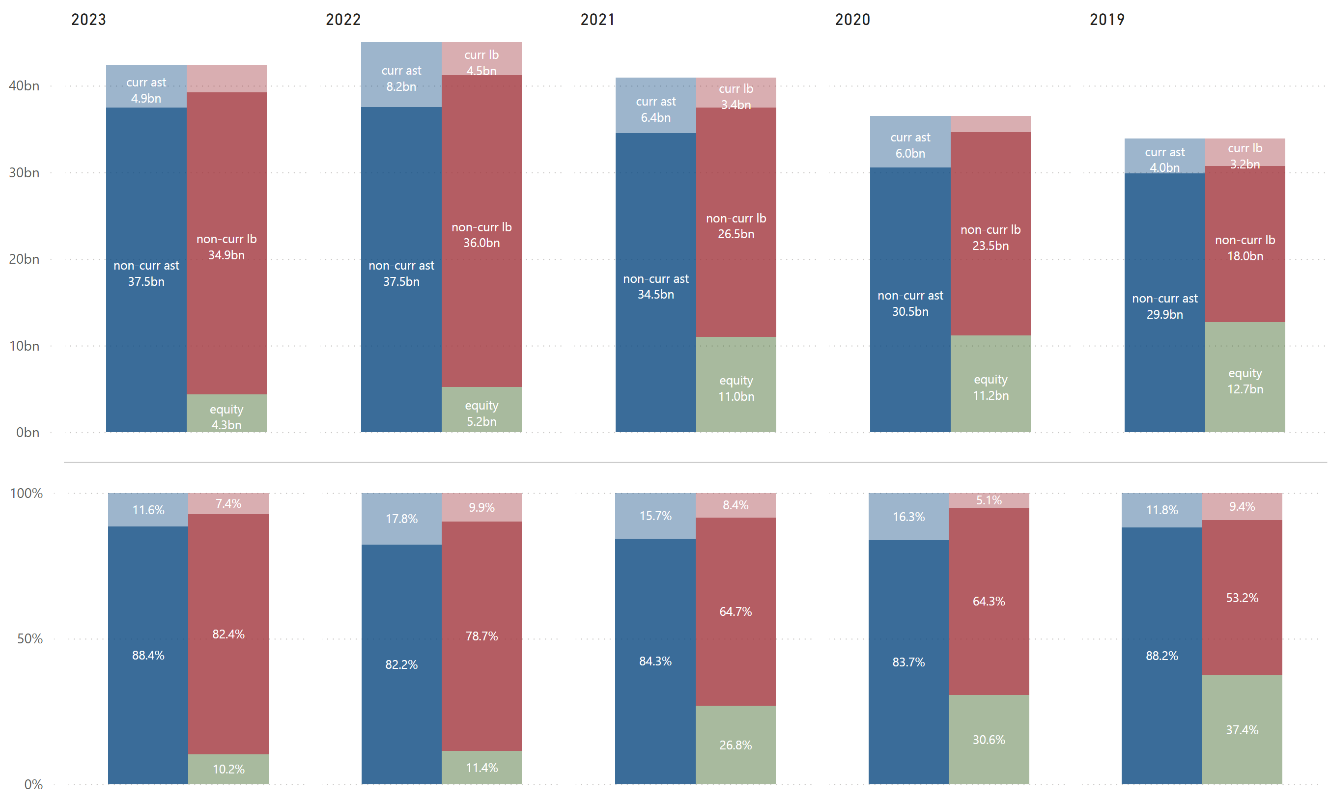

### P/L Chart

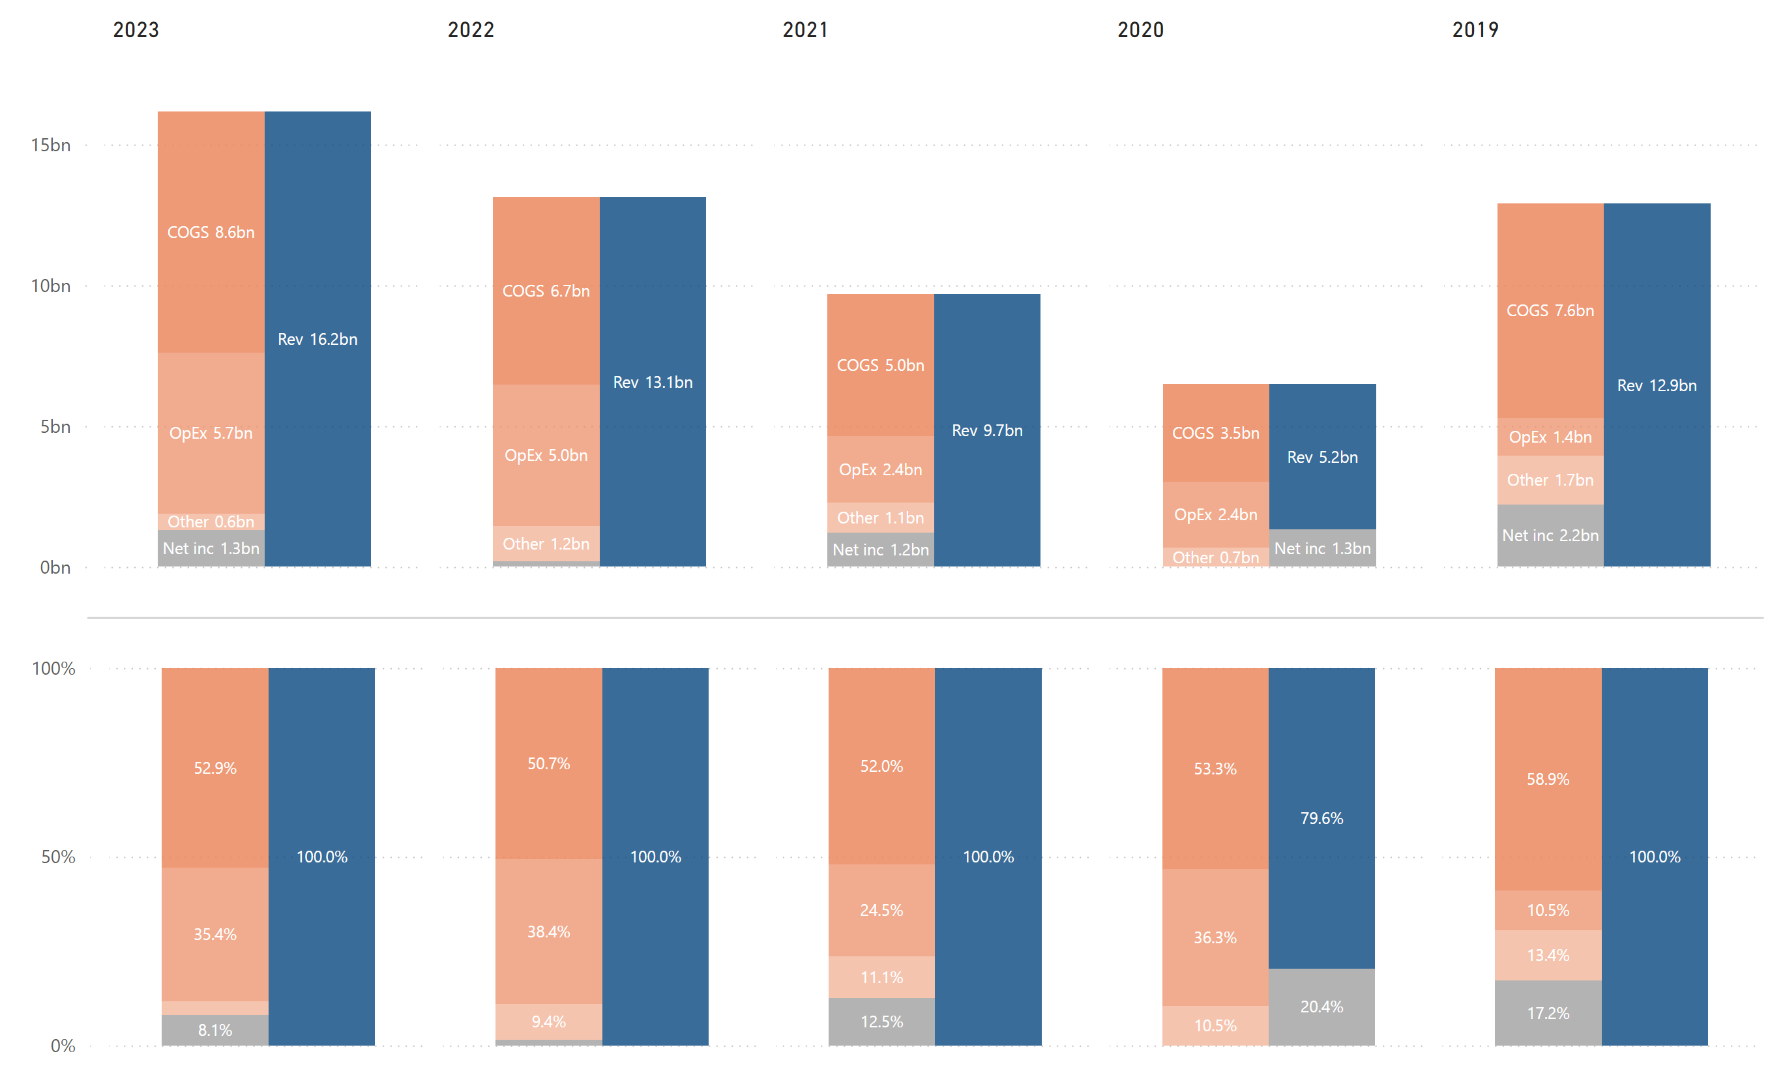

### Cash Flow Chart

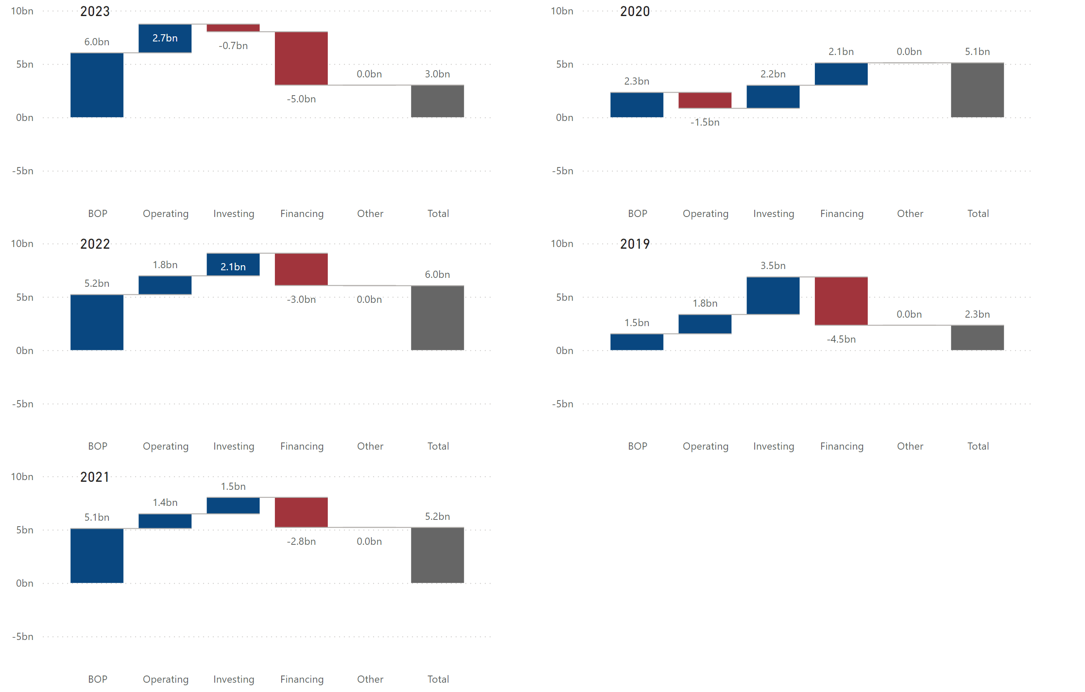

### Historical Financial Ratios



### Long-Term Debt (Most Recent Years)

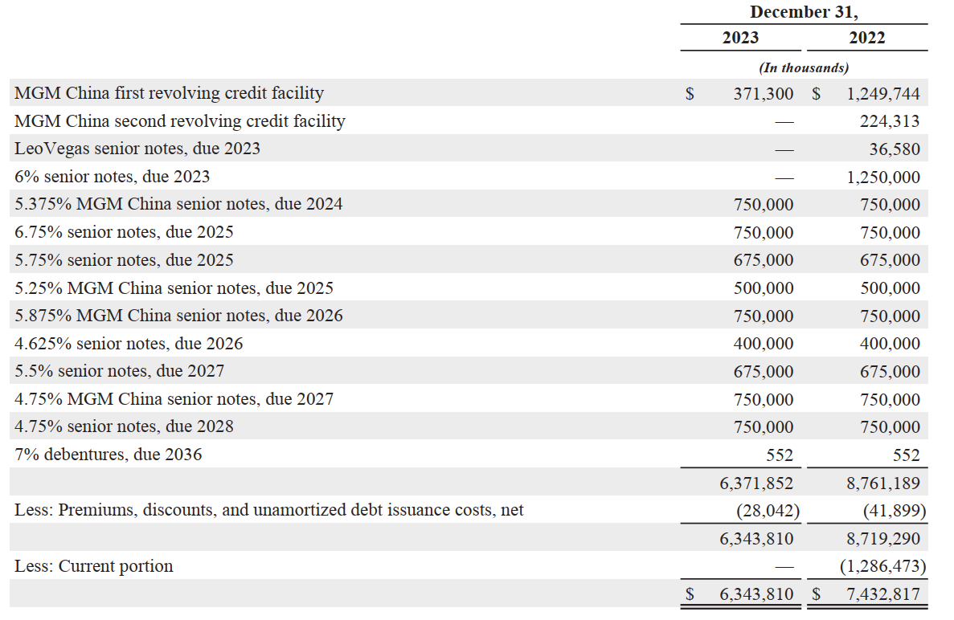

### Maturities of Long-Term Debt / Estimated Debt Service Requirements

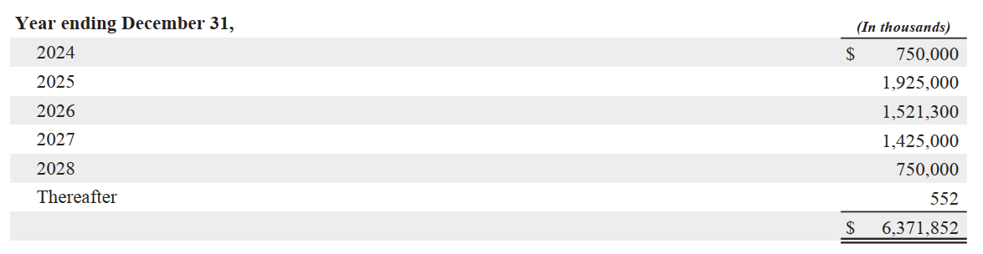

### Key Financial Insights

* (BS) ***The total assets (or liabilities + equity) increased in 4 consecutive years since 2019 to 2022 while it decreased in 2023***.
  + The decrease in 2023 was mainly due to cash spent on financing activities exceeding net cash provided by operating activities, primarily due to the repayment under bank credit facilities ($1.1 billion), the repayment of long-term debt ($1.3 billion), and repurchases of common stock ($2.3 billion) (refer to MGM’s historical cash flow statement in the supplemental data section).
* (BS) ***Total equity decreased by almost half in 2022.***
  + This significant decrease in total equity in 2022 was primarily due to the deconsolidation of MGM Growth Properties ($3.2 billion) and repurchases of common stock ($2.8 billion) (refer to MGM’s historical equity change statement in the supplemental data section).
* (BS) ***Non-current liabilities increased by 14% ($9.5 billion) in 2022.***
  + VICI acquired MGM Growth Properties in a stock-for-stock transaction (the “VICI Transaction”) in 2022. In connection with the VICI Transaction, the company entered into an amended and restated master lease with VICI, which resulted in much more operating lease liabilities on its balance sheet, and it drove the overall increase in non-current liabilities in 2022 (refer to MGM’s historical balance sheet in the supplemental data section).
* (BS/PL) ***While total assets (or liabilities + equity) decreased in 2023, total revenue increased by about $3 billion***.
  + As described earlier, a decrease in total equity in 2023 was primarily due to the debt service and repurchases of common stock.
  + The revenue growth in 2023 was due primarily to MGM China’s full recovery from the COVID-19 impact. The revenue % of the total from MGM China increased from 5.1% to 19.5% in 2023, with 368% revenue growth (refer to MGM’s Net Revenues & Adjusted EBITDAR by Segment in the supplemental data section).
* (PL) ***The company had a higher operating expense % in 2020, 2022 and 2023.***
  + The higher operating expense % in 2022 was primarily due to an increase of rent expense related to the Aria and Vdara, VICI, and The Cosmopolitan leases, which commenced in September 2021, April 2022, and May 2022, respectively, as well as other increases, primarily in payroll costs.
  + Additionally, depreciation and amortization expense increased by 203% in 2022 (refer to MGM’s historical operating expenses in the supplemental data section), due primarily to an increase in the amortization expense of the MGM Grand Paradise gaming subconcession as a result of the change in its useful life.
  + The operating expense % in 2023 was slightly lower than in 2022, primarily due to the aforementioned MGM Grand Paradise gaming subconcession, which became fully amortized in 2022.
  + The main reason for the higher operating expense % in 2020 was mainly due to a negative net income, mainly resulting from the impact of the COVID-19 pandemic.
* (CF) ***The company had positive cash flows from operating activities in the last 5 years except for 2020. The company had positive cash flows from investing activities since 2019 through 2022, but they turned negative in 2023. The company had negative cash flows from financing activities in the last 5 years except for 2020.***
  + The company’s cash flows from operating, investing, and financing activities were **“+, +, -“** respectively in 2019, 2021, and 2022. This indicates that the company is trying to improve its capital structure by generating cash from operating and investing activities (sale of assets, securities, etc.) and actively using them to service its debt or improve its equity structure.
    - In MGM’s case, the company generated cash from several real estate transactions in addition to sufficient cash from operating activities and used them to pay off its debt while also spending on repurchases of common shares, aligning with the company’s asset-light strategy (refer to MGM’s historical cash flow statement in the supplemental data section).
  + In 2020, the company’s cash flows from operating, investing, and financing activities were **“-, +, +”** respectively. This is a typical cash flow pattern many companies with financial problems have.
    - However, in MGM’s case, the company had this cash flow pattern only in 2020, likely covering its loss from operating activities (mainly due to COVID-19) by borrowing while also continuing to deploy its asset-light strategy by selling assets (refer to MGM’s historical cash flow statement in the supplemental data section).
  + In 2023, the company’s cash flows from operating, investing, and financing activities were **“+, -, -”** respectively. This indicates that the company generated sufficient cash from operating activities and used it to not only invest in its growth opportunities but also improving its capital structure (liabilities or equity). This is one of the healthiest cash flow patterns companies can have.
    - In MGM’s case, the company’s investing activities in 2023 became much less active than the last few years. The company did not spend much on acquisitions and did not generate much cash from sales of its assets (refer to MGM’s historical cash flow statement in the supplemental data section). Additionally, there are no assets held for sale on the balance sheet for 2023 (refer to MGM’s historical balance sheet in the supplemental data section). While the company will likely continue to seek opportunities to divest its real estate assets or acquire businesses, it is also possible that moving forward, the company might start spending a lot more on its growth opportunities (particularly online sports-betting/gaming) or repurchases of common shares to return value to shareholders.
* (Ratio) ***The company’s financial leverage has increased for 5 consecutive years.***
  + This supports the company’s asset-light strategy. In fact, its financial leverage of 9.23 is higher than its competitors (refer to solvency ratios comparison on page 9).
* (Ratio) ***The company appears to have a small gap between EBIT Margin and Pre-Tax Margin in general.***
  + This indicates that the company has been successfully and effectively managing its debt obligations. In fact, the gap of 2.9% was the smallest among its competitors (refer to profitability ratios comparison on page 8).
* (Debt) ***The company has maturities of long-term debt of about $1.9 billion, and $1.5 billion, and $1.4 billion in 2025, 2026, and 2027, respectively***.
  + With a combination of the company’s free cash flow (refer to MGM’s historical cash flow statement in the supplemental data section) and new borrowing (or refinancing), the company should be able to service its future debt maturities without any issues.

**Caesars Entertainment

### Employees & Labor Relations

As of December 31, 2023, the company has approximately 51,000 Team Members throughout its organization, excluding the Team Members of certain of its tribal partners. Approximately 24,000, or 47% of our Team Members, are covered by collective bargaining agreements with certain of our subsidiaries.

### Business

As of December 31, 2023, the company owns, leases or manages an aggregate of 52 domestic properties in 18 states. In addition, the company has other properties in North America that are authorized to use the brands and marks of Caesars Entertainment, Inc.

The company’s primary source of revenue is generated by its casino properties’ gaming operations, which includes its retail and online sports betting and online gaming, and the company utilizes its hotels, restaurants, bars, entertainment, racing, retail shops and other services to attract customers to its properties.

As of December 31, 2023, the company owned 22 casinos and leased 24 casinos in the U.S. The company leases 18 casinos from VICI Properties L.P. and six casinos from GLP Capital, L.P. Additionally, the company leased the Rio All-Suite Hotel & Casino (“Rio”) from a separate third party until October 2, 2023, at which time operations were assumed by the lessor.

The company operates and conducts retail and online sports wagering across 31 jurisdictions in North America, 25 of which offer online sports betting. Additionally, the company operates iGaming in five jurisdictions in North America.

### Key Risk Factors Unique to Caesars Entertainment

* The company relies on third parties to provide services that are essential to the operation of its online betting and gaming business, including, player account management, geolocation and identity verification, payment processing and sports data.
* The growth of the company’s digital business will depend, in part, on the success of its strategic relationships with third parties like NFL.

### Properties (as of Dec. 31, 2023)

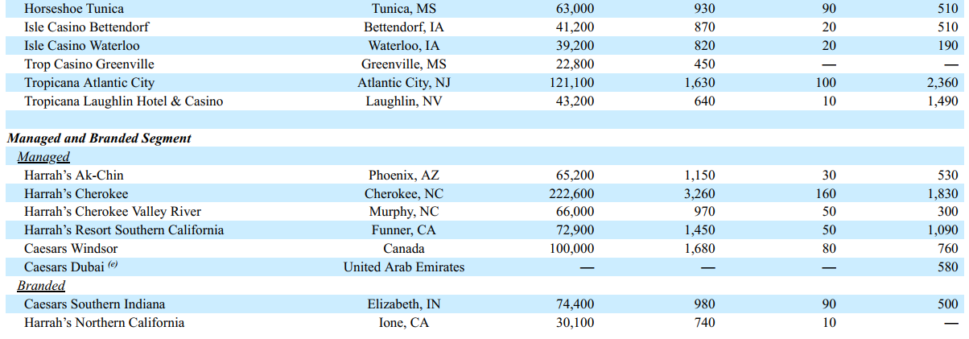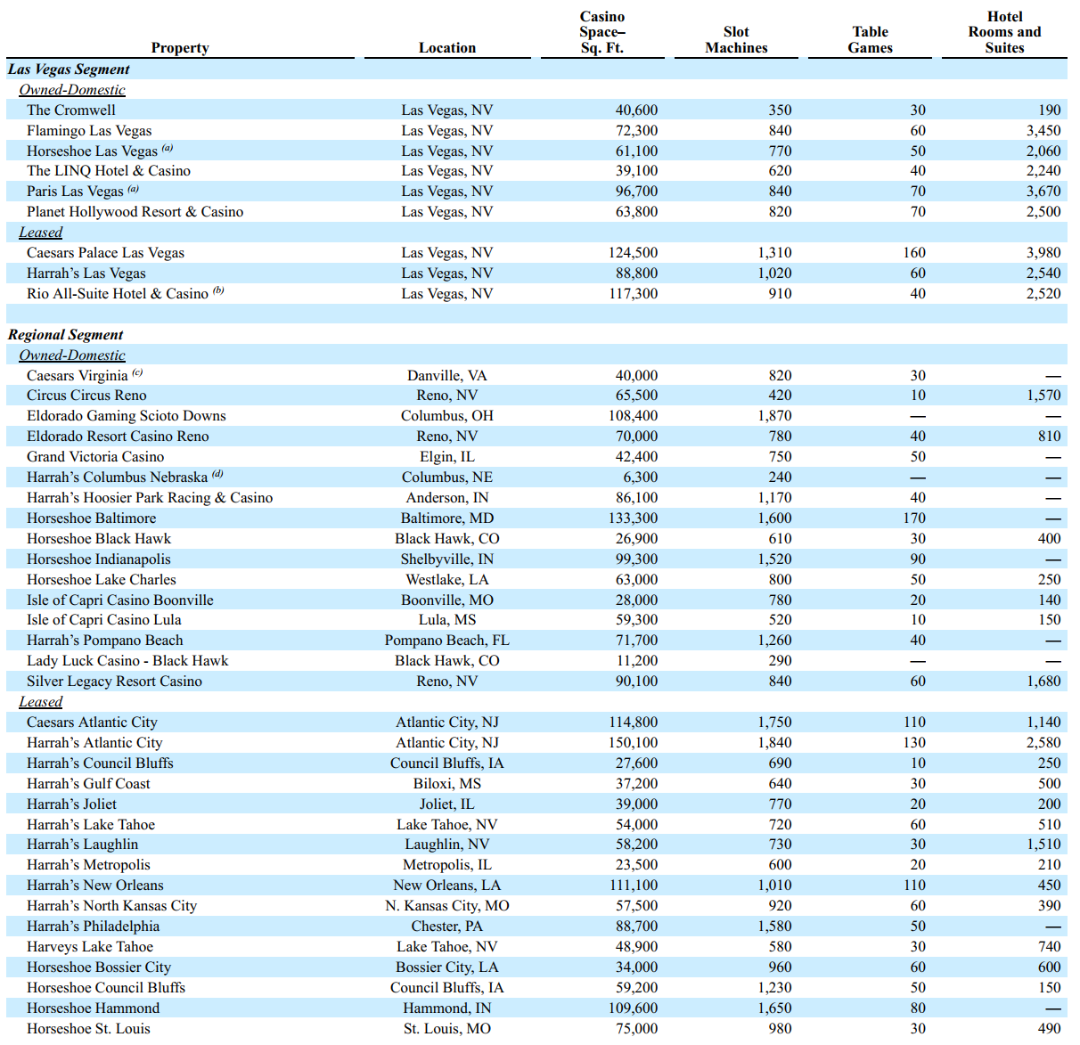

### Balance Sheet Chart

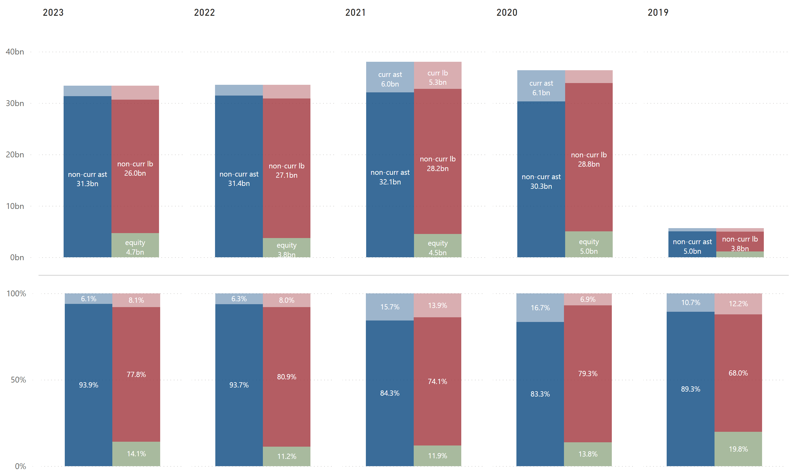

### P/L Chart

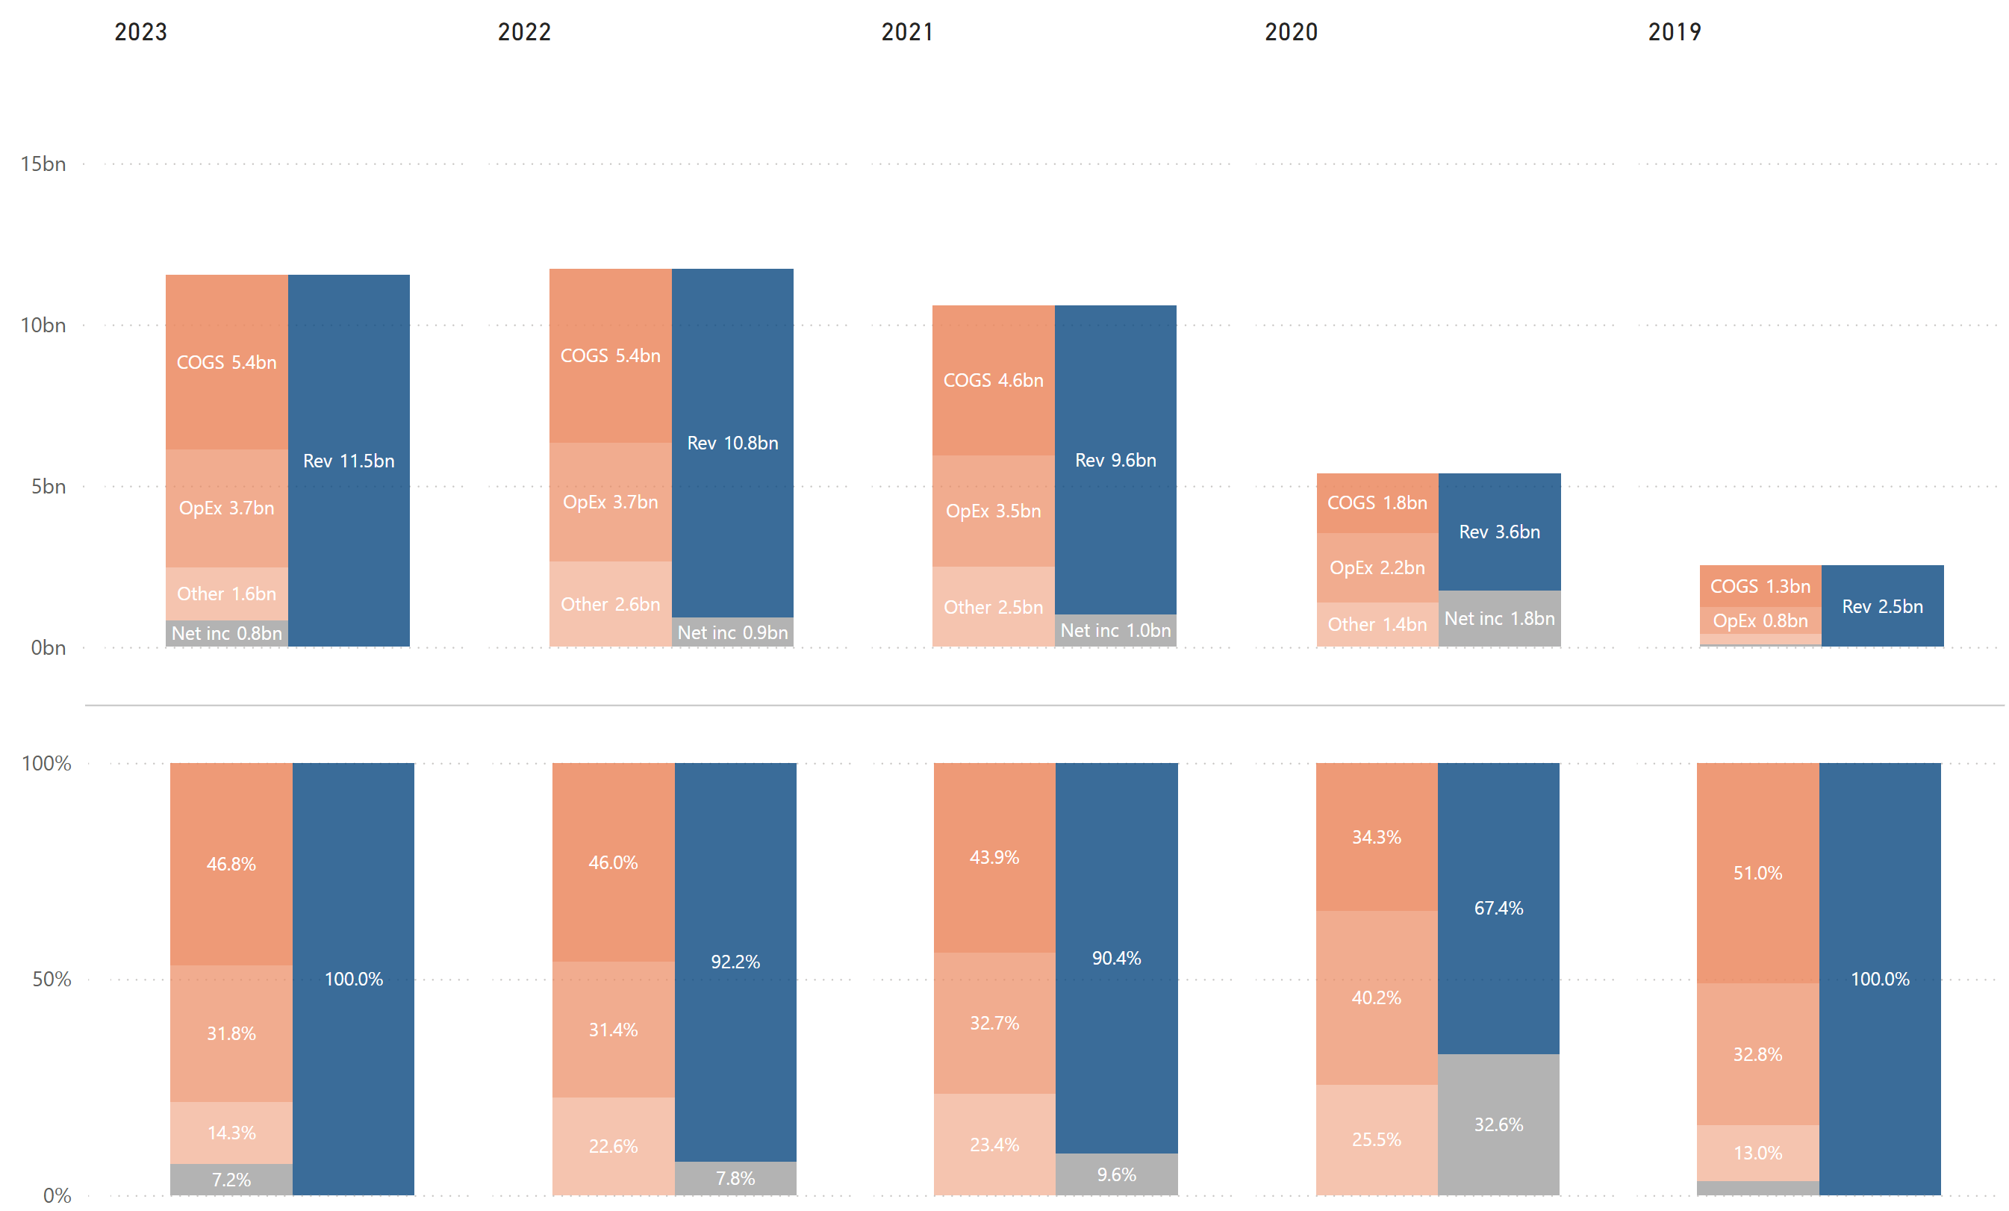

### Cash Flow Chart

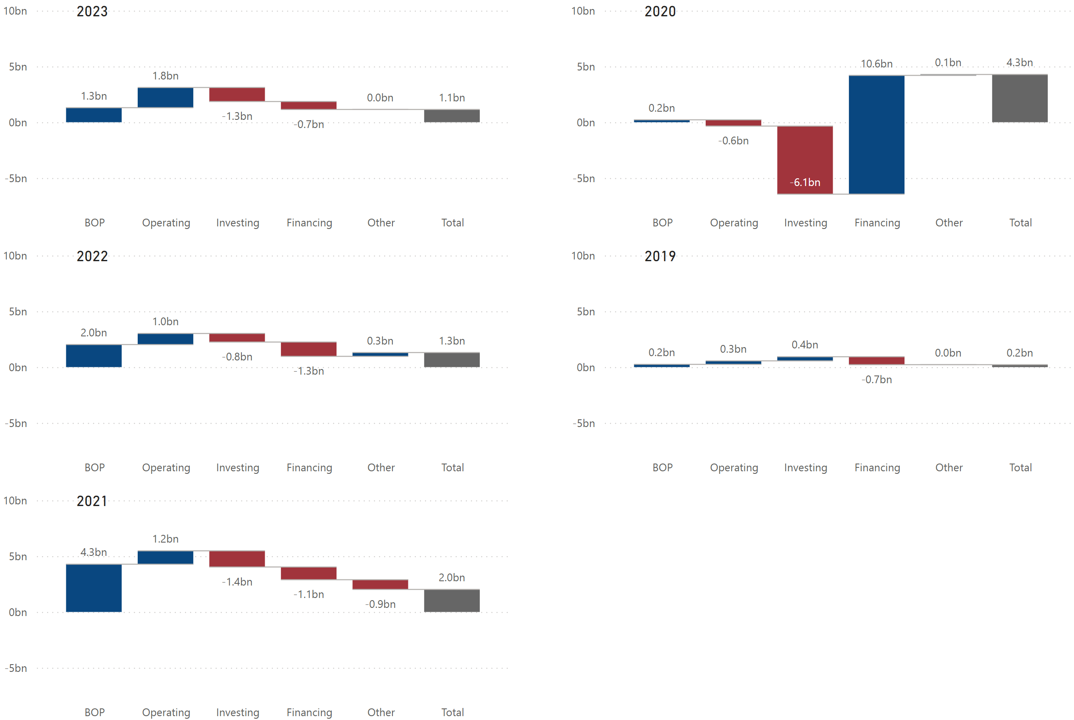

Historical Financial Ratios



### Long-Term Debt (Most Recent Years)

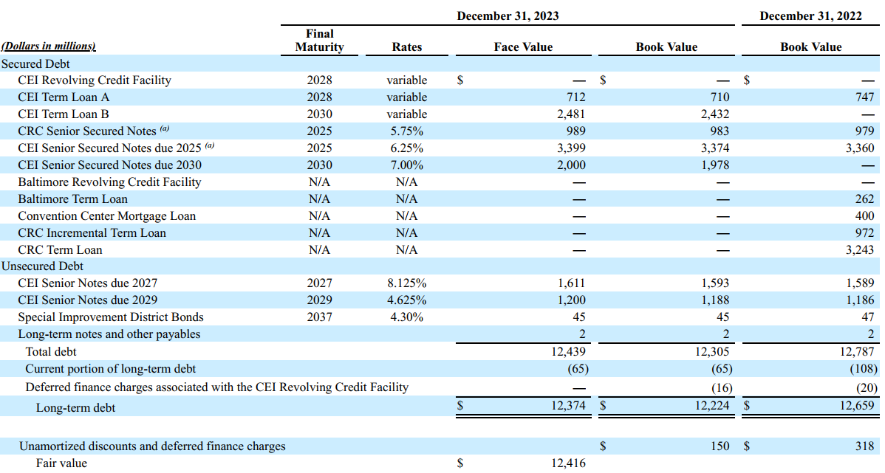

### Maturities of Long-Term Debt / Estimated Debt Service Requirements

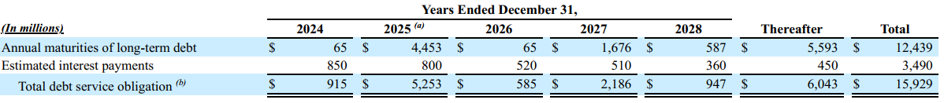

### Key Financial Insights

* (BS) ***Total assets (or liabilities + equity) increased significantly in 2020 and slightly in 2021***.
  + The significant increase in total assets in 2020 was primarily due to its merger with Eldorado Resorts. The combined entity retained the Caesars Entertainment name and expanded its portfolio significantly, leading to a substantial increase in total assets. In connection with the merger, the company also completed the sale of several properties.
  + The slight increase in 2021 was primarily driven by an increase in intangible assets, including goodwill related to the acquisition of William Hill and the consolidation of Horseshoe Baltimore (refer to Caesars’ historical balance sheet in supplemental data section).
* (BS) ***Total assets (or liabilities + equity) decreased in 2022 and remained flat in 2023.***
  + The company had assets held for sale in 2021 and 2020 while it did not have any in 2022 and 2023, which resulted in a decrease in total assets for those years (refer to Caesars’ historical balance sheet in supplemental data section).
* (PL) ***The company had negative net income in 2020, 2021, and 2022.***
  1. The company’s negative net income in 2020 was mainly due to the COVID-19 pandemic. The company’s net revenues were lower than its operating expenses that year, leading to negative operating income as well (refer to Caesars’ historical P/L statement in the supplemental data section).
  + The negative net income in 2021 and 2022 was due primarily to interest expenses surpassing its operating income (refer to Caesars’ historical P/L statement in the supplemental data section).
* (PL) ***There was a significant increase in total revenue in 2021***.
  + The increase was primarily due to the merger, the William Hill acquisition, and the consolidation of Horseshoe Baltimore, offset by the divestiture of certain properties. In addition, net revenues for the year ended December 31, 2020, were negatively impacted by the COVID-19 public health emergency.
* (PL/Ratio) ***The company’s Gross Profit Margin % has been higher than MGM’s***.
  + There are 2 possible reasons. One is that the company is more efficient in generating revenues than MGM. Another is that the company pays less to its employees.
    - The company’s 5-year average fixed assets turnover is 0.5 lower than MGM, which indicates that MGM is more efficient in utilizing its fixed assets (PP&E) to produce higher sales (refer to Caesars’ and MGM’s historical financial ratios).
    - The company’s 5-year average total assets turnover is 0.01 higher than MGM, which indicates that the company may be utilizing its current assets (inventory, AR, etc.) more efficiently than MGM. In fact, the company’s 5-year average DSO and DIO are lower than MGM’s while its 5-year average DPO is higher than MGM’s (refer to Caesars’ and MGM’s historical financial ratios).
    - Based on rough calculations, MGM’s revenue per employee for 2023 was $212,687 ($16 billion total revenue / 76,000 employees) and Caesars’ was $226,039 ($12 billion total revenue / 51,000 employees). This could indicate that Caesars’ workforce productivity might be more efficient than MGM’s.
    - According to Indeed and Glassdoor, MGM tends to pay more to employees based on job posts or reports by employees (not adjusted for level or location).
    - Based on the factors above, the company’s higher gross profit margin % can be explained by more efficient operations and/or lower wages.
* (PL/Debt) ***The company’s other expense % has been significantly higher than MGM’s***.
  + As their interest coverage ratios indicate (refer to solvency ratios comparison on page 9), both Caesars and MGM are financially leveraged. However, it is important to note that Caesars is financially leveraged due to its long-term debt, while MGM is financially leveraged due to its lease liabilities (refer to Caears’ and MGM’s historical balance sheet in the supplemental data section).
    - Caesars’ long-term debt is almost double that of MGM’s, and a company is typically required to pay off long-term debt within much shorter periods than lease liabilities. This results in much larger annual interest payments for Caesars, compared to MGM.
    - MGM generates sufficient operating income to easily cover its interest payments (operating lease cost is classified within “General and Administrative,” which is under operating expenses), while Caesars’ operating income has been either just enough or insufficient to cover its interest payments.
* (CF) ***The company had significantly large negative cash flows from investing activities and significantly large positive cash flows from financing activities in 2020. Since 2021 through 2023, the company’s cash flows from operating, investing, and financing activities have been “+, -, -“ respectively.***
  + The company’s large negative cash flows from investing activities in 2020 were primarily due to the former Caesars acquisition ($6.3 billion). It appears that the company covered the acquisition cost by financing long-term debt ($9.8 billion), issuing common stocks ($2.7 billion), and proceeding from sale-leaseback financing arrangement ($3.2 billion) (refer to Caesars’ historical cash flow statement in the supplemental data section).
  + As mentioned earlier during the analysis of MGM, a cash flow pattern of “+, -, -” is one of the healthiest cash flow patterns. However, unlike MGM, Caesars has been spending more on investing and financing combined than the cash generated by operating activities from 2021 through 2023, and its EOP cash balance has been decreasing.
    - The company’s negative cash flows from investing activities over the last 3 years were primarily due to capital expenditures and the William Hill acquisition in 2021 (refer to Caesars’ historical cash flow statement in the supplemental data section).
  + It is unclear how much liquidity the company is trying to maintain, but it cannot continue spending at the same rate; otherwise, it will keep losing cash.
* (Debt) ***The company has an estimated debt payment of about $5.3 billion and $2.2 billion in 2025 and 2027, respectively.***
  + The company will likely refinance or replace its debt facilities when they mature as the company has been doing in the last few years. While it does not appear that the company has delayed interest payments so far, being forced to restructure debt or failing to obtain financing on commercially reasonable terms would be a red flag.

## PENN Entertainment

### Employees & Labor Relations

As of December 31, 2023, we had approximately 23,333 full-time and part-time employees. We had 35 collective bargaining agreements covering approximately 4,180 active employees.

### Business

As of December 31, 2023, PENN operated 43 properties in 20 states, online sports betting in 18 jurisdictions and iCasino in five jurisdictions, under a portfolio of well-recognized brands including Hollywood Casino, L'Auberge, ESPN BET, and theScore Bet Sportsbook and Casino.

In August 2023, PENN entered into a transformative, exclusive long-term strategic alliance with ESPN, Inc. and ESPN Enterprises, Inc. (together, “ESPN”) relating to online sports betting within the United States. PENN's ability to leverage the leading sports media brands in the United States (ESPN) and Canada (theScore) will position us to significantly expand its digital footprint and efficiently grow its customer ecosystem. This highly differentiated strategy, which is focused on organic cross-sell opportunities, is reinforced by its market-leading retail casinos, sports media assets, and technology, including a proprietary state-of-the-art, fully integrated digital sports and iCasino betting platform and an in-house iCasino content studio.

PENN's portfolio is further bolstered by its industry-leading PENN Play customer loyalty program, which offers over 29 million members a unique set of rewards and experiences across business channels.

The majority of the real estate assets (i.e., land and buildings) used in the company’s operations are subject to triple net master leases; the most significant of which are with Gaming and Leisure Properties, Inc. (Nasdaq: GLPI) (“GLPI”), a real estate investment trust (“REIT”), and include the AR PENN Master Lease, 2023 Master Lease, PENN Master Lease (prior to January 1, 2023), and Pinnacle Master Lease.

### Key Risk Factors Unique to PENN Entertainment

* The company is reliant on its partnership with ESPN, and the failure to maintain that relationship could negatively impact its business, reputation, and strategic goals.

### Properties (as of Dec. 31, 2023)

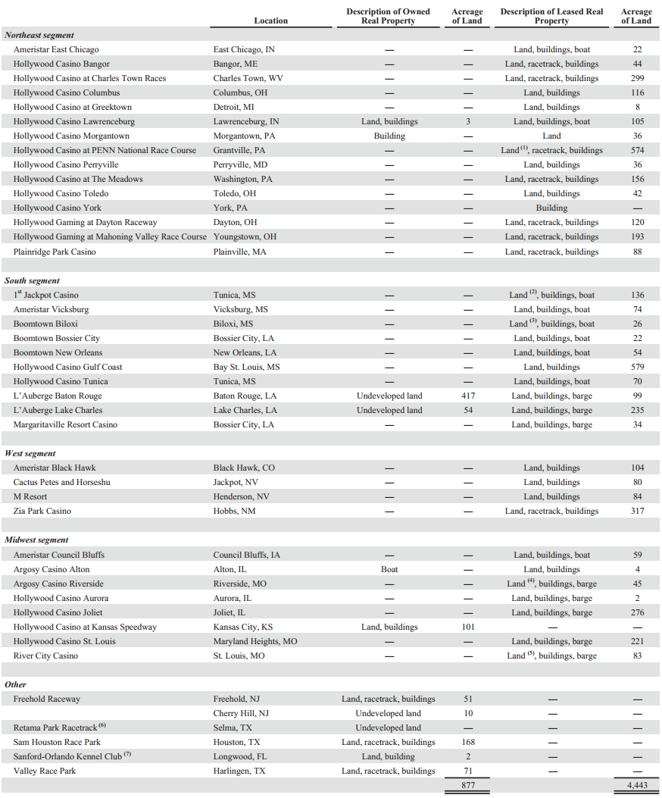

### Balance Sheet Chart

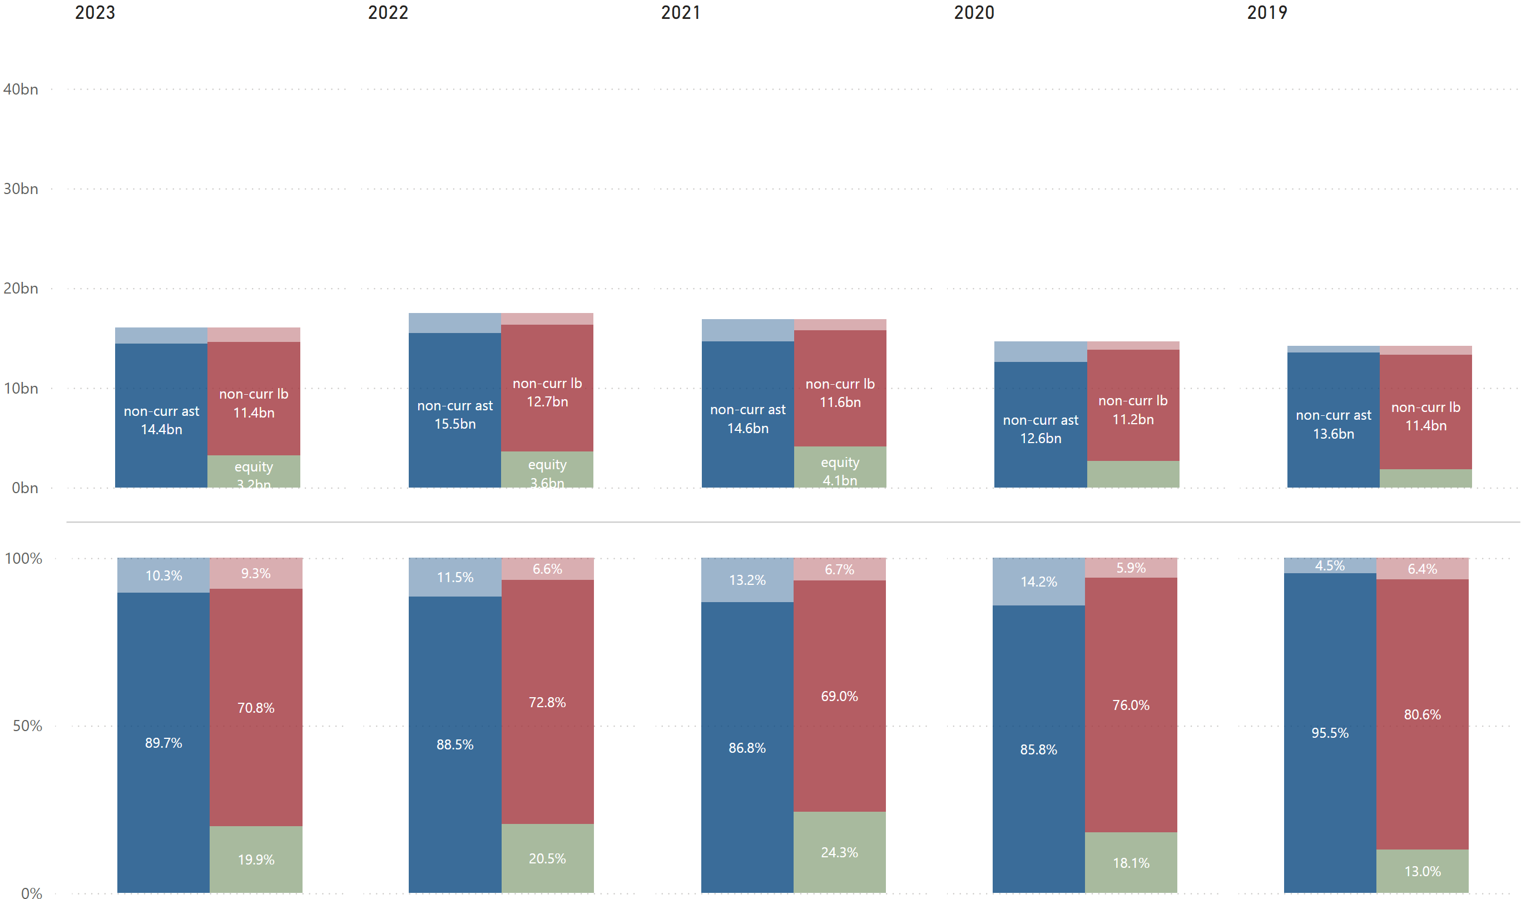

### P/L Chart

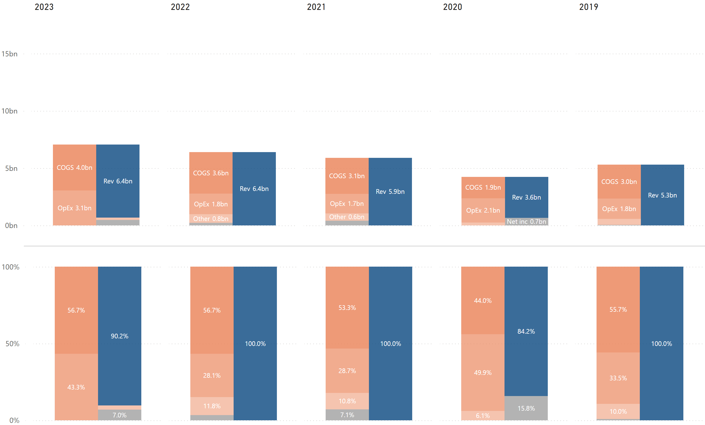

### Cash Flow Chart

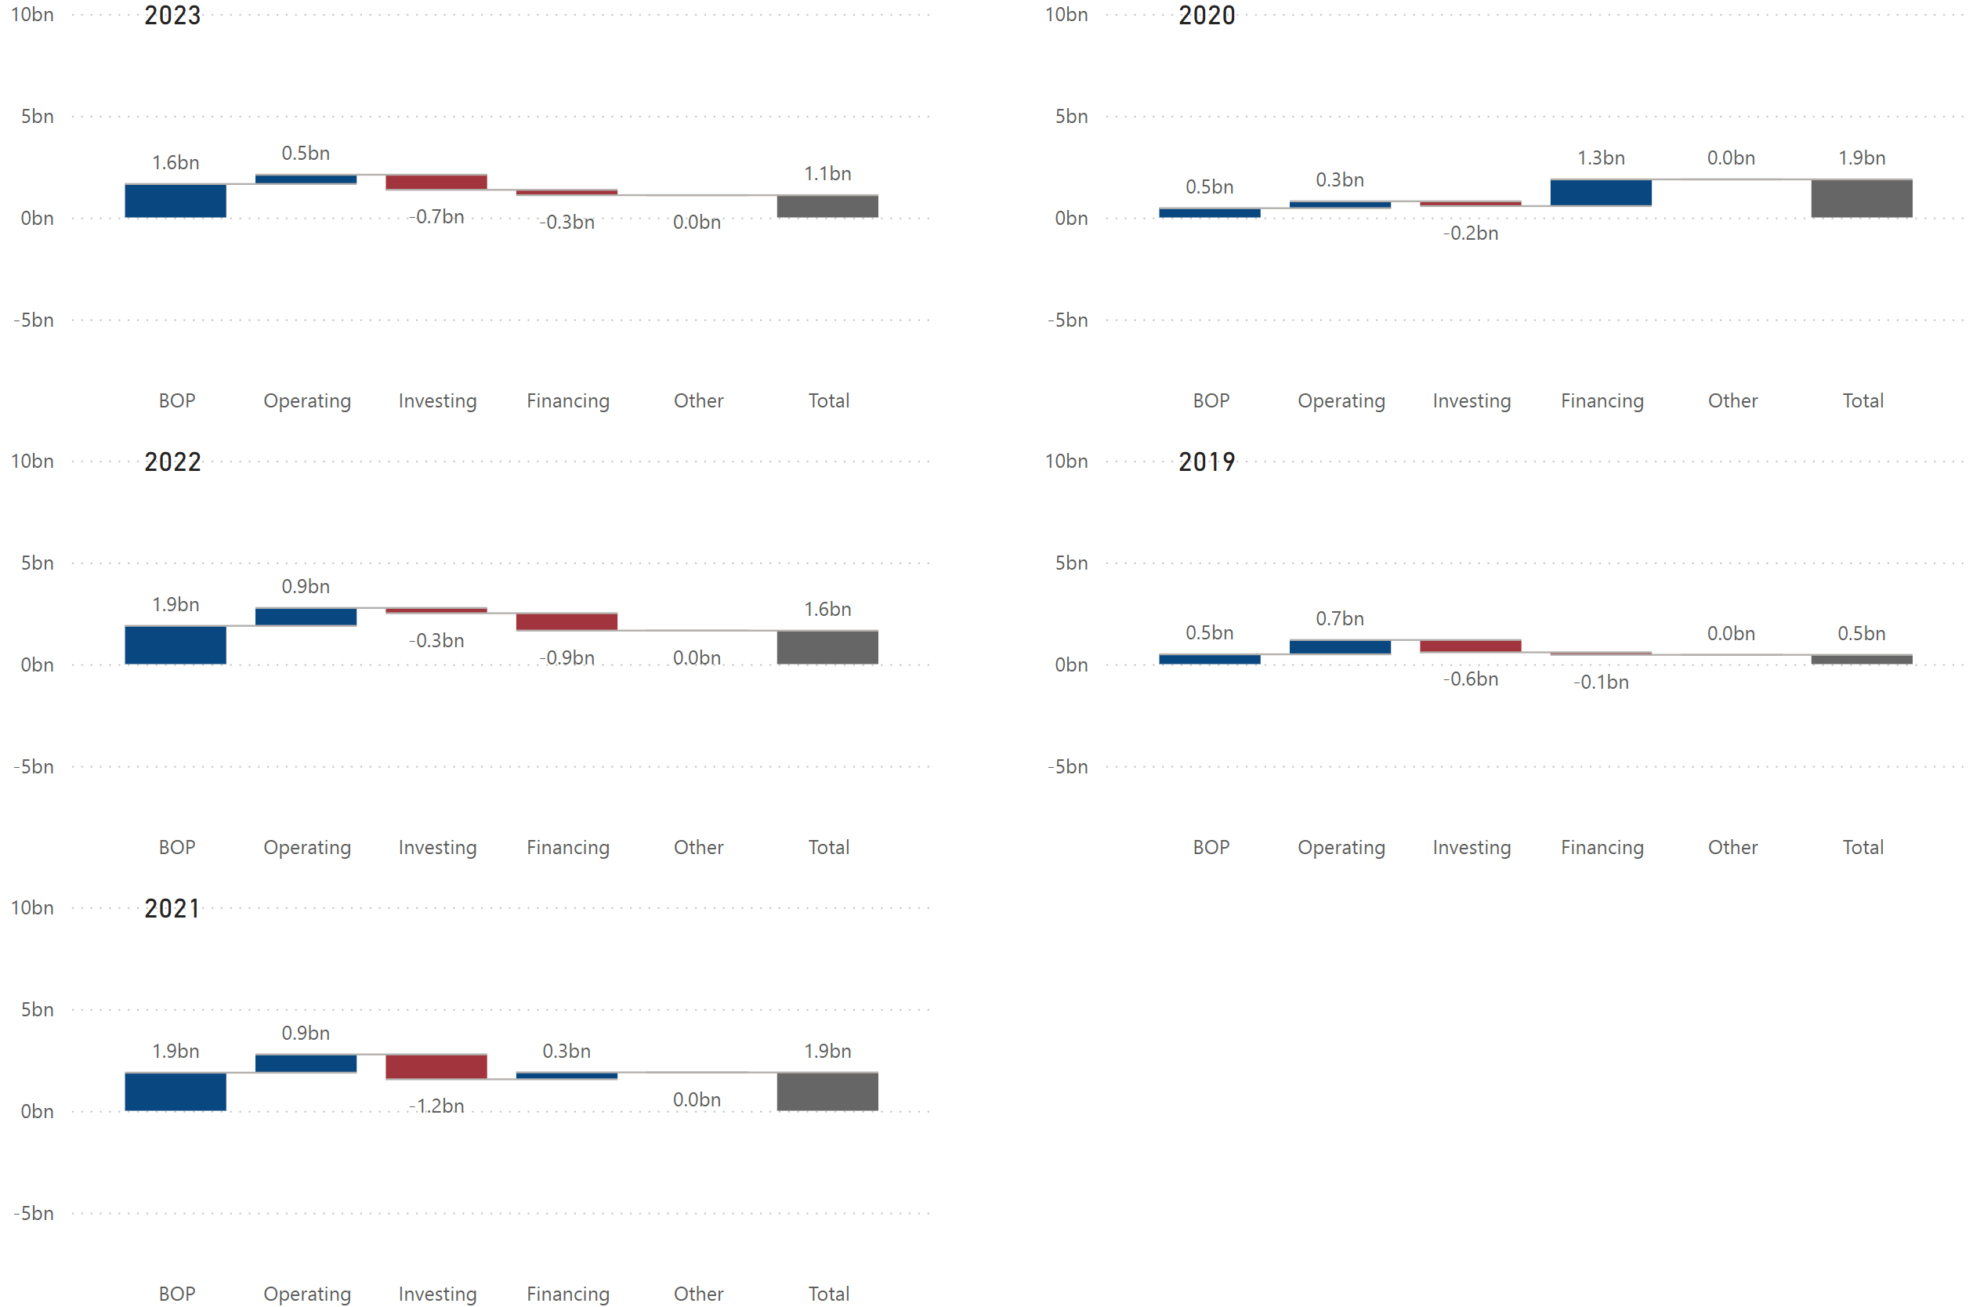

### Historical Financial Ratios



### Long-Term Debt (Most Recent Years)

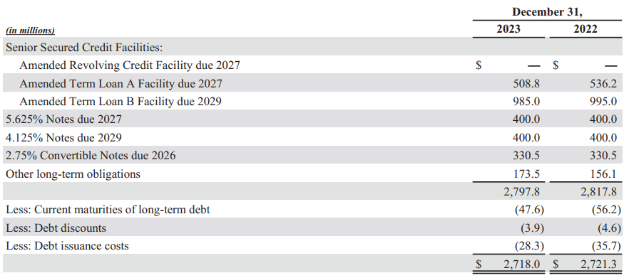

### Maturities of Long-Term Debt / Estimated Debt Service Requirements

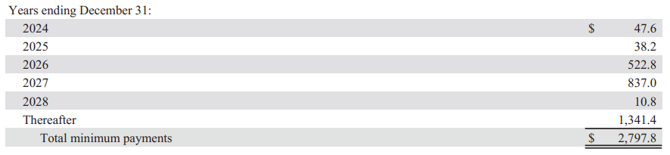

### Key Financial Insights

* (BS) ***The company’s Equity % increased by 6.2% in 2021 and decreased by 3.8% in 2022***.
  + In 2021, the company issued shares in connection with acquisitions (refer to PENN’ historical cash flow statement in the supplemental data section), which drove the 54% increase in equity (refer to PENN’ historical balance sheet in the supplemental data section). The related acquisitions include HitPoint (an independent game design and development studio), Sam Houston (Race Park), and theScore (sports betting platform provider).
  + The decrease in 2022 was driven primarily due to share repurchases ($601 million) (refer to PENN’s historical cash flow statement).
* (PL) ***The company had other “income” instead of “expense” in 2023***.
  + The company’s other income included a net gain of $83 million from the Barstool acquisition, and a net gain of $501 million from REIT transactions (refer to PENN’s historical P/L statement in the supplemental data section). When MGM and Wynn had gains from similar transactions in previous years, they classified them within operating expenses, while PENN classified them within other income (expense).
* (PL/Ratio) ***The company’s COGS % are very high, leading to its lowest Gross Profit Margin % and EBITDAR Margin among its competitors***.
  + There are a few possible reasons for this. One is that the company is less efficient in generating revenues. Another possibility is that the company has higher employee expenses. It is also possible that the company’s win % for slot/table games are lower than those of its competitors.
    - Rough calculations indicate that the company generates $273 million per employee ($6,363 million total revenue / 23,333 employees), which is higher that MGM and Caesars. PENN seems to be efficient in terms of employee productivity.
    - The company’s fixed assets turnover and total assets turnover were roughly around the industry average (refer to activity ratios comparison on page 10), indicating that the company is as efficient in generating revenues from assets as its competitors.
    - The company only reported their typical range of win %, stating that the lower end for table games is 12% and for slot games is 7%, which is lower than MGM and Caesars (refer to each company’s KPIs in the supplemental data section). Although we cannot be sure, if the company’s win % have been on the lower end, it is possible that it has been causing its low profitability.
    - About 10% of the company’s revenues come from the “Interactive” segment (refer to PENN’s KPIs in the supplemental data section). While its revenues are growing, its adjusted EBITDAR has been negative, mainly due to promotional incentives and marketing expense upon the launch of ESPN BET. This resulted in an even lower EBITDAR margin in 2023.
* (PL) ***The company had negative net income in 2020 and 2023.***
  + The company’s negative net income in 2020 was primarily due to the COVID-19 pandemic. The pandemic caused significant disruptions to its business and had a material adverse impact on its financial condition, results of operations and cash flows.
  + The company’s negative net income in 2023 was primarily due to the loss on the sale of 100% of the outstanding shares of Barstool to David Portnoy in exchange for nominal cash consideration.
    - In February 2023, the company acquired the remaining 64% of the outstanding shares of Barstool Sports, Inc. common stock not already owned by the company.
    - In August 2023, the company entered into a Sportsbook Agreement with ESPN, which provides for a long-term strategic relationship between PENN and ESPN relating to online sports betting in the United States. The company rebranded the existing Barstool Sportsbook across all online platforms in the United States as ESPN BET.
* (CF) ***In 2020 and 2021, the company’s cash flows from operating, investing, and financing activities were “+, -, +“ respectively***. ***In 2022 and 2023, the company’s cash flows from operating, investing, and financing activities were “+, -, -“ respectively.***
  + A cash flow pattern of “+, -, +” can be seen when a company actively invests in its growth with a clear strategic plan by preparing more cash from financing activities on top of cash from operating activities.
    - In PENN’s case, the company purchased 36% of the common stock of Barstool Sports in 2020 to enter an online sports betting market and raised additional capital by issuing common stock (refer to PENN’s historical cash flow statement in the supplemental data section).
    - In 2021, the company used cash it prepared in 2020 to acquire multiple businesses, including HitPoint, Hollywood Casino Perryville, Sam Houston Race Park, and theScore (refer to PENN’s historical cash flow statement in the supplemental data section).
  + In 2022, the company did not have any acquisitions and therefore spent much less on investing. The company’s negative cash flows from financing activities in 2022 were primarily due to repurchase of common stock (refer to PENN’s historical cash flow statement in the supplemental data section).
  + In 2023, the company repurchased its common stock again but spent less, likely because it spent more on investing activities (specifically, consideration paid for the Barstool acquisition) (refer to PENN’s historical cash flow statement in the supplemental data section).
  + The company’s EOP cash balance has been decreasing since 2022, but given that the company has been using cash to repurchase its common stock over the past 2 years, it is likely that the company believes that it has sufficient liquidity and a decrease in the EOP cash balance does not hurt its financial position.
* (Debt) ***The company has much larger amounts of debt maturities in 2026 ($523 million) and 2027 ($837 million).***
  + The capacity under the company’s Amended Revolving Credit Facility is $1.0 billion, of which $978.3 million was available as of December 31, 2023.
  + The company’s free cash flow in the last 3 years was $652 million, $615 million, $96 million (due to a one-off loss on disposal of Barstool) in 2021, 2022, 2023, respectively (refer to PENN’s historical cash flow statement in the supplemental data section).
  + Given the factors above, the combination of cash from operating and financing activities will likely be able to cover its future debt obligations, though it can restrict its ability to invest in its growth.

## Wynn Resorts

### Employees & Labor Relations

As of December 31, 2023, the company had approximately 27,800 employees (including approximately 11,300 in Macau and 16,500 in the United States).

The company’s collective bargaining agreement with the Culinary Workers Union, Local 226, and Bartenders Union, Local 165, which covers approximately 6,220 culinary, housekeeping, public area, and front services employees at Wynn Las Vegas, is effective from August 1, 2023 through November 30, 2028.

Wynn Las Vegas entered into a collective bargaining agreement with the United Auto Workers Union ("UAW") effective August 28, 2021 through August 28, 2024, covering approximately 370 table games dealer employees.

Wynn Las Vegas entered into a collective bargaining agreement with the International Brotherhood of Teamsters effective July 21, 2021 through July 21, 2024, covering approximately 160 horticulture and valet employees.

Wynn Las Vegas entered into a collective bargaining agreement with the UAW effective from January 27, 2023 through January 27, 2027, covering approximately 70 slot attendant employees.

The company’s collective bargaining agreement with UNITE HERE Local 26 affiliated with UNITE HERE and International Brotherhood of Teamsters, Chauffeurs, Warehousemen & Helpers, Local 25, which covers approximately 1,400 employees at Encore Boston Harbor, expires on August 31, 2026.

In October 2023, slot attendant employees at Encore Boston Harbor voted to be represented by UNITE HERE Local 26 under the terms of the existing Collective Bargaining Agreement.

Effective as of July 2021, Encore Boston Harbor entered into a collective bargaining agreement with Local 103, International Brotherhood of Electrical Workers, AFL-CIO. The collective bargaining agreement covers approximately 110 maintenance employees at Encore Boston Harbor, and expires in June 2024. Effective as of August 2022, Encore Boston Harbor entered into a collective agreement with United Government Security Officers of America, Local 295. The collective bargaining agreement covers approximately 150 security officers at Encore Boston Harbor and expires in June 2025.

### Business

Through its approximately 72% ownership of Wynn Macau, Limited ("WML"), the company’s concessionaire Wynn Resorts (Macau) S.A. ("Wynn Macau SA") operates two integrated resorts in the Macau Special Administrative Region ("Macau") of the People's Republic of China ("PRC"), Wynn Palace and Wynn Macau (collectively, our "Macau Operations").

In Las Vegas, Nevada, the company operates and, with the exception of certain retail space, owns 100% of Wynn Las Vegas. Additionally, the company is a 50.1% owner and managing member of a joint venture that owns and leases certain retail space at Wynn Las Vegas (the "Retail Joint Venture").

In Everett, Massachusetts, the company operates Encore Boston Harbor, an integrated resort.

The company also holds an approximately 97% interest in, and consolidate, Wynn Interactive Ltd.("Wynn Interactive"), through which the company operates online sports betting, gaming, and social casino businesses.

Additionally, the company has a 40% equity interest in Island 3 AMI FZ-LLC, an unconsolidated affiliate, which is currently constructing an integrated resort property ("Wynn Al Marjan Island") in RasAl Khaimah, United Arab Emirates.

### Key Risk Factors Unique to Wynn Resorts

* The company is entirely dependent on a limited number of resorts for all of its cash flow, which subjects the company to greater risks than a gaming company with more operating properties.
* If its Macau Operations fails to comply with the Gaming Concession Contract, or applicable Macau laws, the Macau government may rescind the company’s concession without compensation to the company, which would have a material adverse effect on its business and financial condition.

### Properties (as of Dec. 31, 2023)

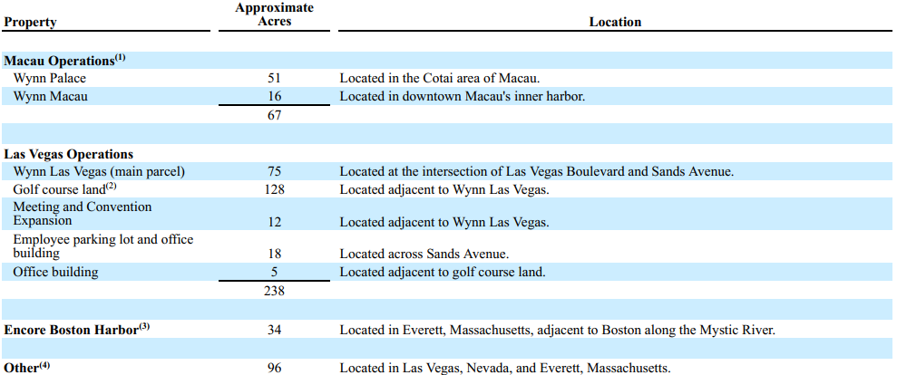

### Balance Sheet Chart

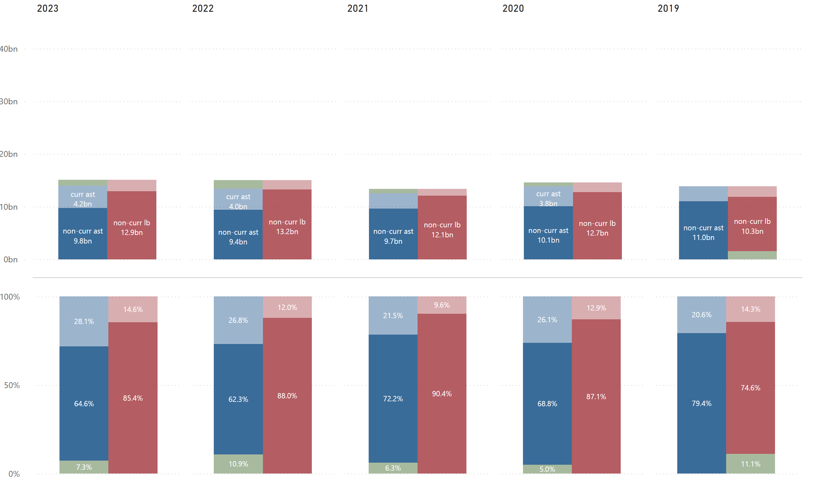

### P/L Chart

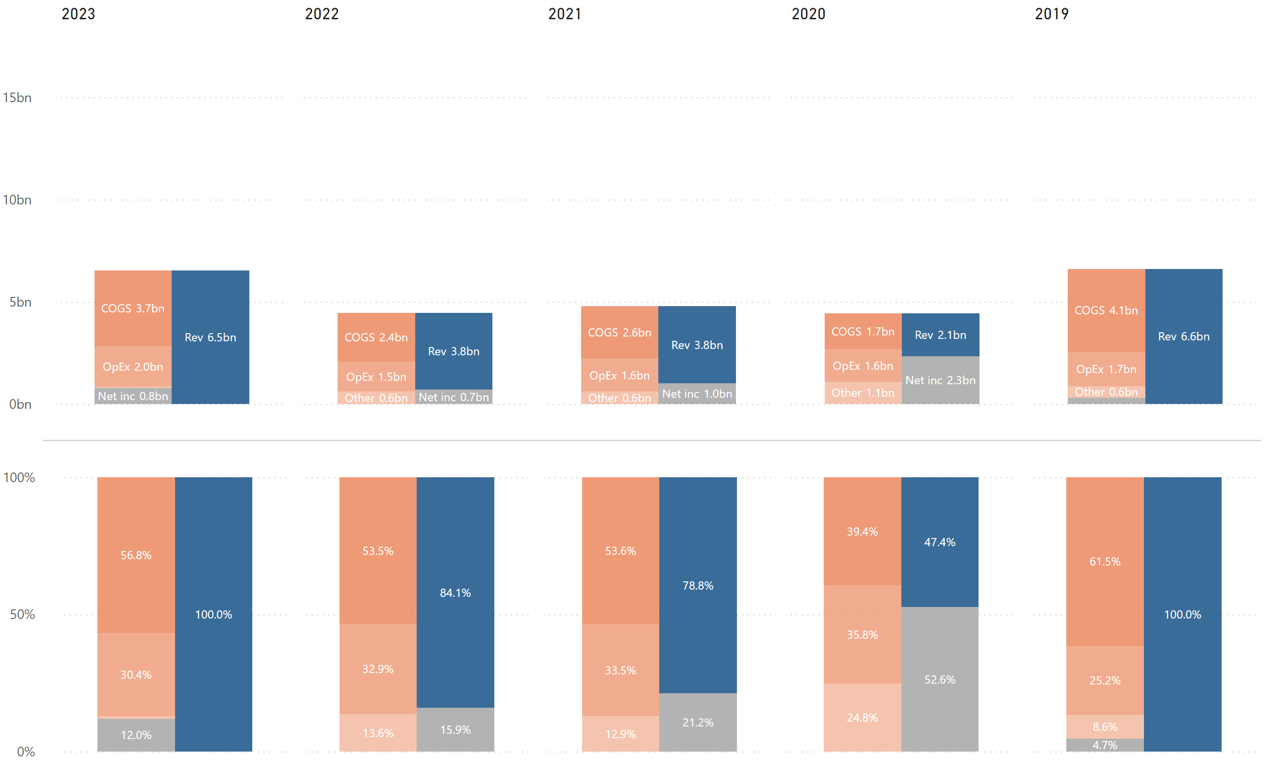

### Cash Flow Chart

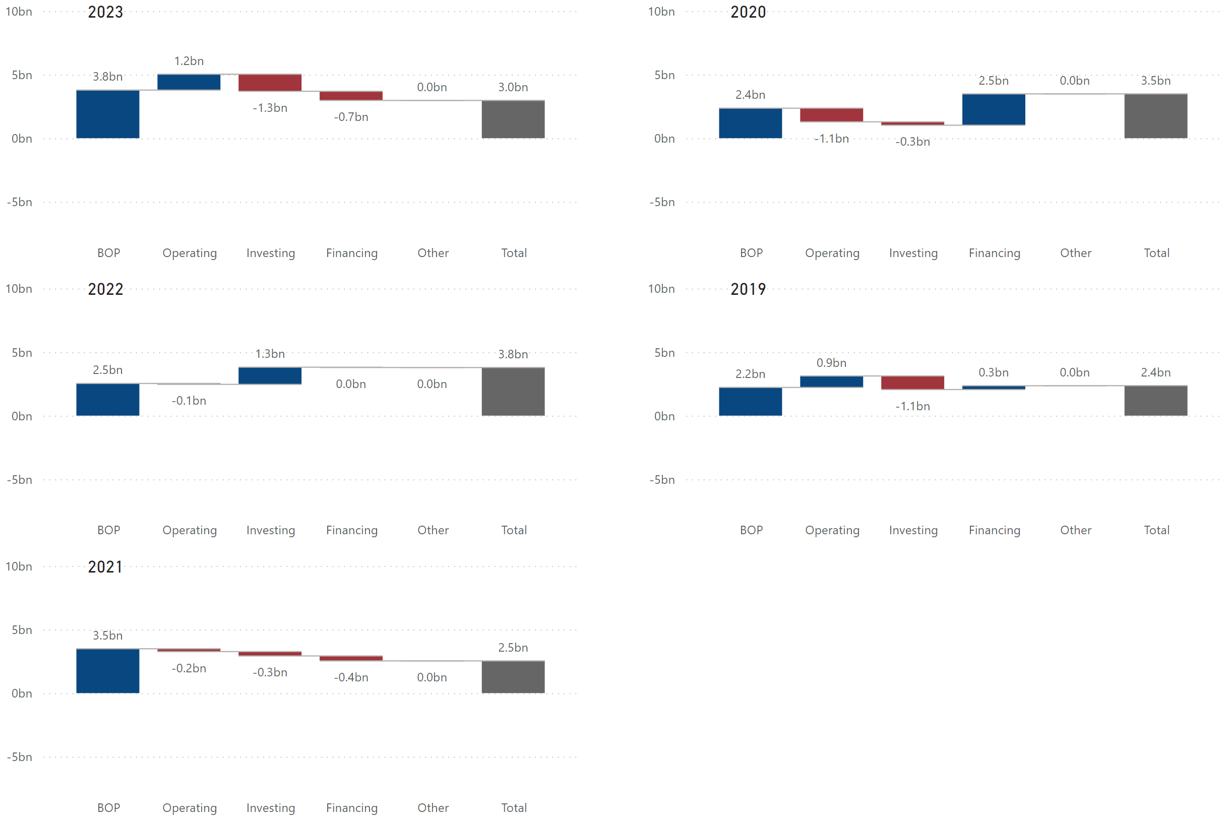

### Historical Financial Ratios



Long-Term Debt (Most Recent Years)

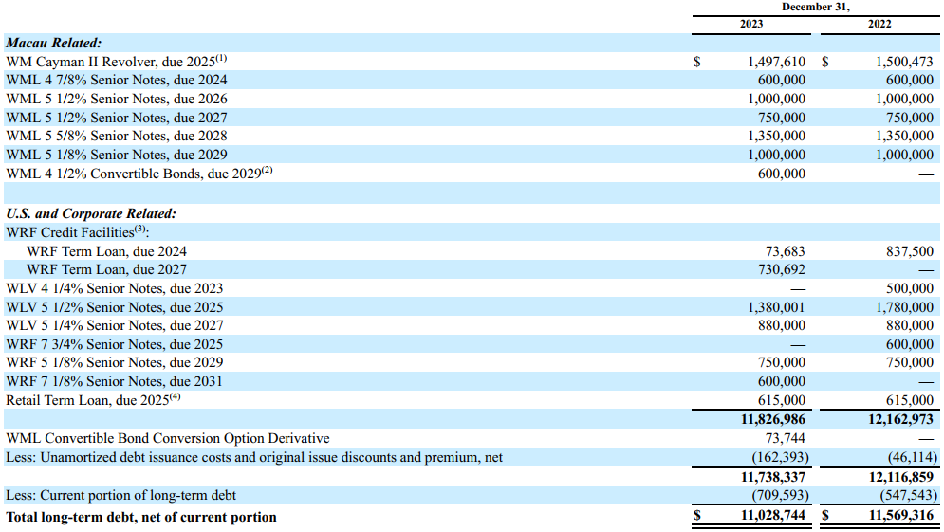

### Maturities of Long-Term Debt / Estimated Debt Service Requirements

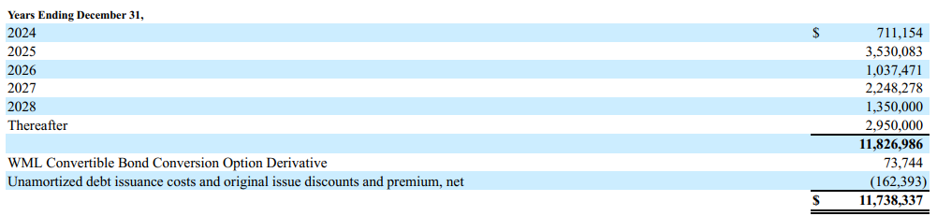

### Key Financial Insights

* (BS) ***The company’s total equity has been negative since 2020***.
  + The company’s total equity first turned negative in 2020, primarily due to a net loss of $2.3 billion, mainly due to the COVID-19 pandemic. As mentioned in the “Risk Factors Unique to Wynn Resorts” section, the company is entirely dependent on a limited number of resorts in Macau, Las Vegas, and Boston. Travel restrictions in the regions where the company operates (especially Macau) had a significant adverse impact on the company’s results of operations.
  + In 2021, the company had net loss of $1.0 billion, resulting in an increase in total negative equity, partially offset by issuance of common stock worth $842 million (refer to Wynn’s historical equity statement in the supplemental data section).
  + In 2022, the company had a net loss of $709 million and repurchased more common stock ($188 million) than in previous years, which caused total negative equity to almost double (refer to Wynn’s historical equity statement in the supplemental data section).
  + In 2023, the company was finally able to improve the accumulated deficit with a net income of $782 million, which also decreased total negative equity, partially offset by $212 million of share repurchases and $84 million cash dividends declared (refer to Wynn’s historical equity statement in the supplemental data section).
  + There are a few possible reasons why the company decided to repurchase common stock despite its equity deficit and keep it as treasury stock.
    - Resale: the company believes that its stock price will increase.
    - Flexibility for Future Use: the company will reissue these shares in the future for various purposes, such as employee stock compensation plans, stock options, potential acquisition, etc.
    - Strategic Considerations: treasury stock can be used strategically to support or defend against corporate actions such as mergers, acquisitions, or hostile takeovers.
* (BS) ***The company’s current asset % is higher than MGM, Caesars, and PENN***.
  + The company’s balance sheet indicates its high liquidity, mainly comprised of cash and cash equivalents, investments (fixed deposits and debt securities), and accounts receivables (refer to Wynn’s historical Balance Sheet in the supplemental data section).
  + When a company has a higher current asset %, it indicates several possible scenarios regarding its liquidity, operational efficiency, and financial management.
    - The company is more capable of meeting its short-term obligations. In fact, the company’s liquidity ratios are the highest in the industry (refer to liquidity ratios comparison on page 9).
    - The company’s higher liquidity could be a strategic decision to manage working capital conservatively and ensure it has enough liquidity to manage day-to-day operations smoothly and handle unexpected expenses or opportunities. In fact, the company’s defensive interval was 386 days which is the far largest among its competitors (refer to liquidity ratios comparison on page 9).
    - Higher current assets can give the company more flexibility to take advantage of immediate business opportunities, such as acquiring other businesses, investing in new projects, or expanding operations without the need to secure external financing.
    - The company may be adopting a more conservative approach to financial management, holding more liquid assets as a buffer against economic downturns or industry-specific risks.
    - It is also important to consider the potential downsides, such as lower returns. Current assets typically yield lower returns compared to fixed assets due to their nature and the risk-return tradeoff inherent in financial management. If a company holds excessive current assets, it might be missing out on higher returns that could be achieved through long-term investments.
* (PL) ***The company had negative net income in 2020, 2021, and 2022***.
  + The negative net income in 2020 was primarily related to the adverse effects of the COVID-19 pandemic on the results of the company’s operations.
  + The company’s negative net income in 2021 and 2022 was primarily due to its results of operations in China. China implemented a series of restrictions for a longer period in response to the COVID-19 pandemic than the United States. With global vaccination efforts and reduced case numbers, China began easing international travel restrictions further in 2023, which resulted in the first positive net income in 2023 since 2019.
  + Both MGM and Wynn operate in China. However, due to its limited number of resorts, Wynn’s operations in China have much larger impact on its overall results than MGM’s. This explains why the company took a longer time to recover its operational results to pre-pandemic levels.
* (CF) ***In 2020, the company’s cash flows from operating, investing, and financing activities were “-, -, +“ respectively***. ***In 2021, the company’s cash flows from operating, investing, and financing activities were “-, -, -“ respectively***. ***In 2022, the company’s cash flows from operating, investing, and financing activities were “-, +, -“ respectively***. ***In 2023, the company’s cash flows from operating, investing, and financing activities were “+, -, -“ respectively.*** 
  + In 2020, the company had negative cash flows from operating activities, mainly due to the COVID-19 pandemic. The company also had negative cash flows from investing activities, primarily due to capital expenditures (refer to Wynn’s historical cash flow statement in the supplemental data section). Cash outflows by operating and investing activities totaled $1.4 billion. The company had positive cash flows from financing activities, primarily due to the issuance of long-term debt of $4.7 billion (refer to Wynn’s historical cash flow statement in the supplemental data section). It appears that the company kept capital expenditures minimal and took on long-term debt to cover its loss from operations and sustain operations in the coming years.
  + In 2021, the company had negative cash flows from operating (mainly due to its China operations not improving), investing (mainly due to capital expenditures), and financing (mainly due to debt payments, partially offset by the issuance of long-term debt and its common stock) activities. This resulted in about a $1 billion decrease in the EOP cash balance.
  + The company’s positive cash flows of $1.3 billion from investing activities in 2022 was mainly driven by the EBH transaction (sale-leaseback arrangement with respect to certain real estate assets related to Encore Boston Harbor). The gain from the transaction is expected to be used for the reinvestment and asset sale provisions of its senior secured credit facilities.
  + In 2023, the company had positive cash flows from operating activities for the first time since 2020, mainly due to the full recovery of its China operations. The company also spent a total of $1.3 billion on capital expenditures and purchase of investments, intangible and other assets by using the cash gained from the EBH transaction (refer to Wynn’s historical cash flow statement in the supplemental data section). Additionally, the company had negative cash flows from financing activities, primarily due to repurchase of common stock and repayments of long-term debt, partially offset by the issuance of long-term debt.
* (Debt) ***The company has a significant amount of debt maturities in the coming years. The company’s total long-term debt is the second largest after Caesars.***
  + The company seems to have enough cash to cover its debt due in 2024. However, it has much more debt maturities starting in 2025, and will likely need to raise additional capital by selling assets, taking on more debt, and/or issuing common stock. The company indicates that it still has the capacity to incur additional debt if certain conditions are met. However, any failure to service its debt or delay in payments occurred, that would be a red flag.

## A blue and grey logo Description automatically generatedBoyd Gaming

### Employees & Labor Relations

As of December 31, 2023, the company had 16,129 Team Members, including 15,308 Team Members at its properties and 821 Team Members in its corporate function. The company has collective bargaining agreements with three unions covering 1,107 employees.

### Business

Headquartered in Las Vegas, the company operates 28 wholly owned brick-and-mortar gaming entertainment properties in Nevada, Illinois, Indiana, Iowa, Kansas, Louisiana, Mississippi, Missouri, Ohio and Pennsylvania.

In addition, the company owns and operates Boyd Interactive, a business-to-business (“B2B”) and business-to-consumer (“B2C”) online casino gaming business in the United States and Canada. Through a management agreement with Wilton Rancheria, the company also manages the Sky River Casino, which is located in California.

The company has a strategic partnership with and is a 5% equity owner of FanDuel Group, the nation’s leading sports-betting operator. Through its strategic partnership, the company pursues sports-betting opportunities, both at its properties and online, across the country. We operate FanDuel-branded sportsbooks at 16 of our properties. The company also offers online sports-betting under the FanDuel brand in all states that its 28 gaming entertainment properties are located, except in Mississippi and Missouri where online sports-betting has not been legalized and in Nevada where the company operates its own brand, Boyd Sports.

In addition, the company has market access agreements outside of Nevada with other third parties for online sports-betting.

### Key Risk Factors Unique to Boyd Gaming

* The company draws a significant percentage of its customers from certain geographic regions. Events adversely impacting the economy of these regions, including public health outbreaks and man-made or natural disasters, may adversely impact its business.
  + The California, Fremont and Main Street Station draw a substantial portion of their customers from the Hawaiian market, with such customers historically comprising more than half of the room nights sold at each property.
  + The company’s Las Vegas properties also draw a substantial number of customers from specific geographic areas, including the Southern California, Arizona and Las Vegas local markets.

### Properties (as of Dec. 31, 2023)

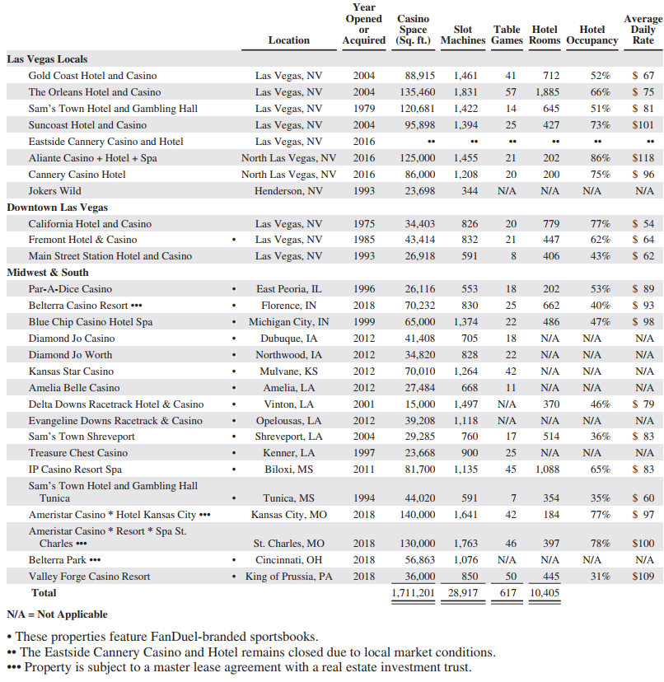

### Balance Sheet Chart

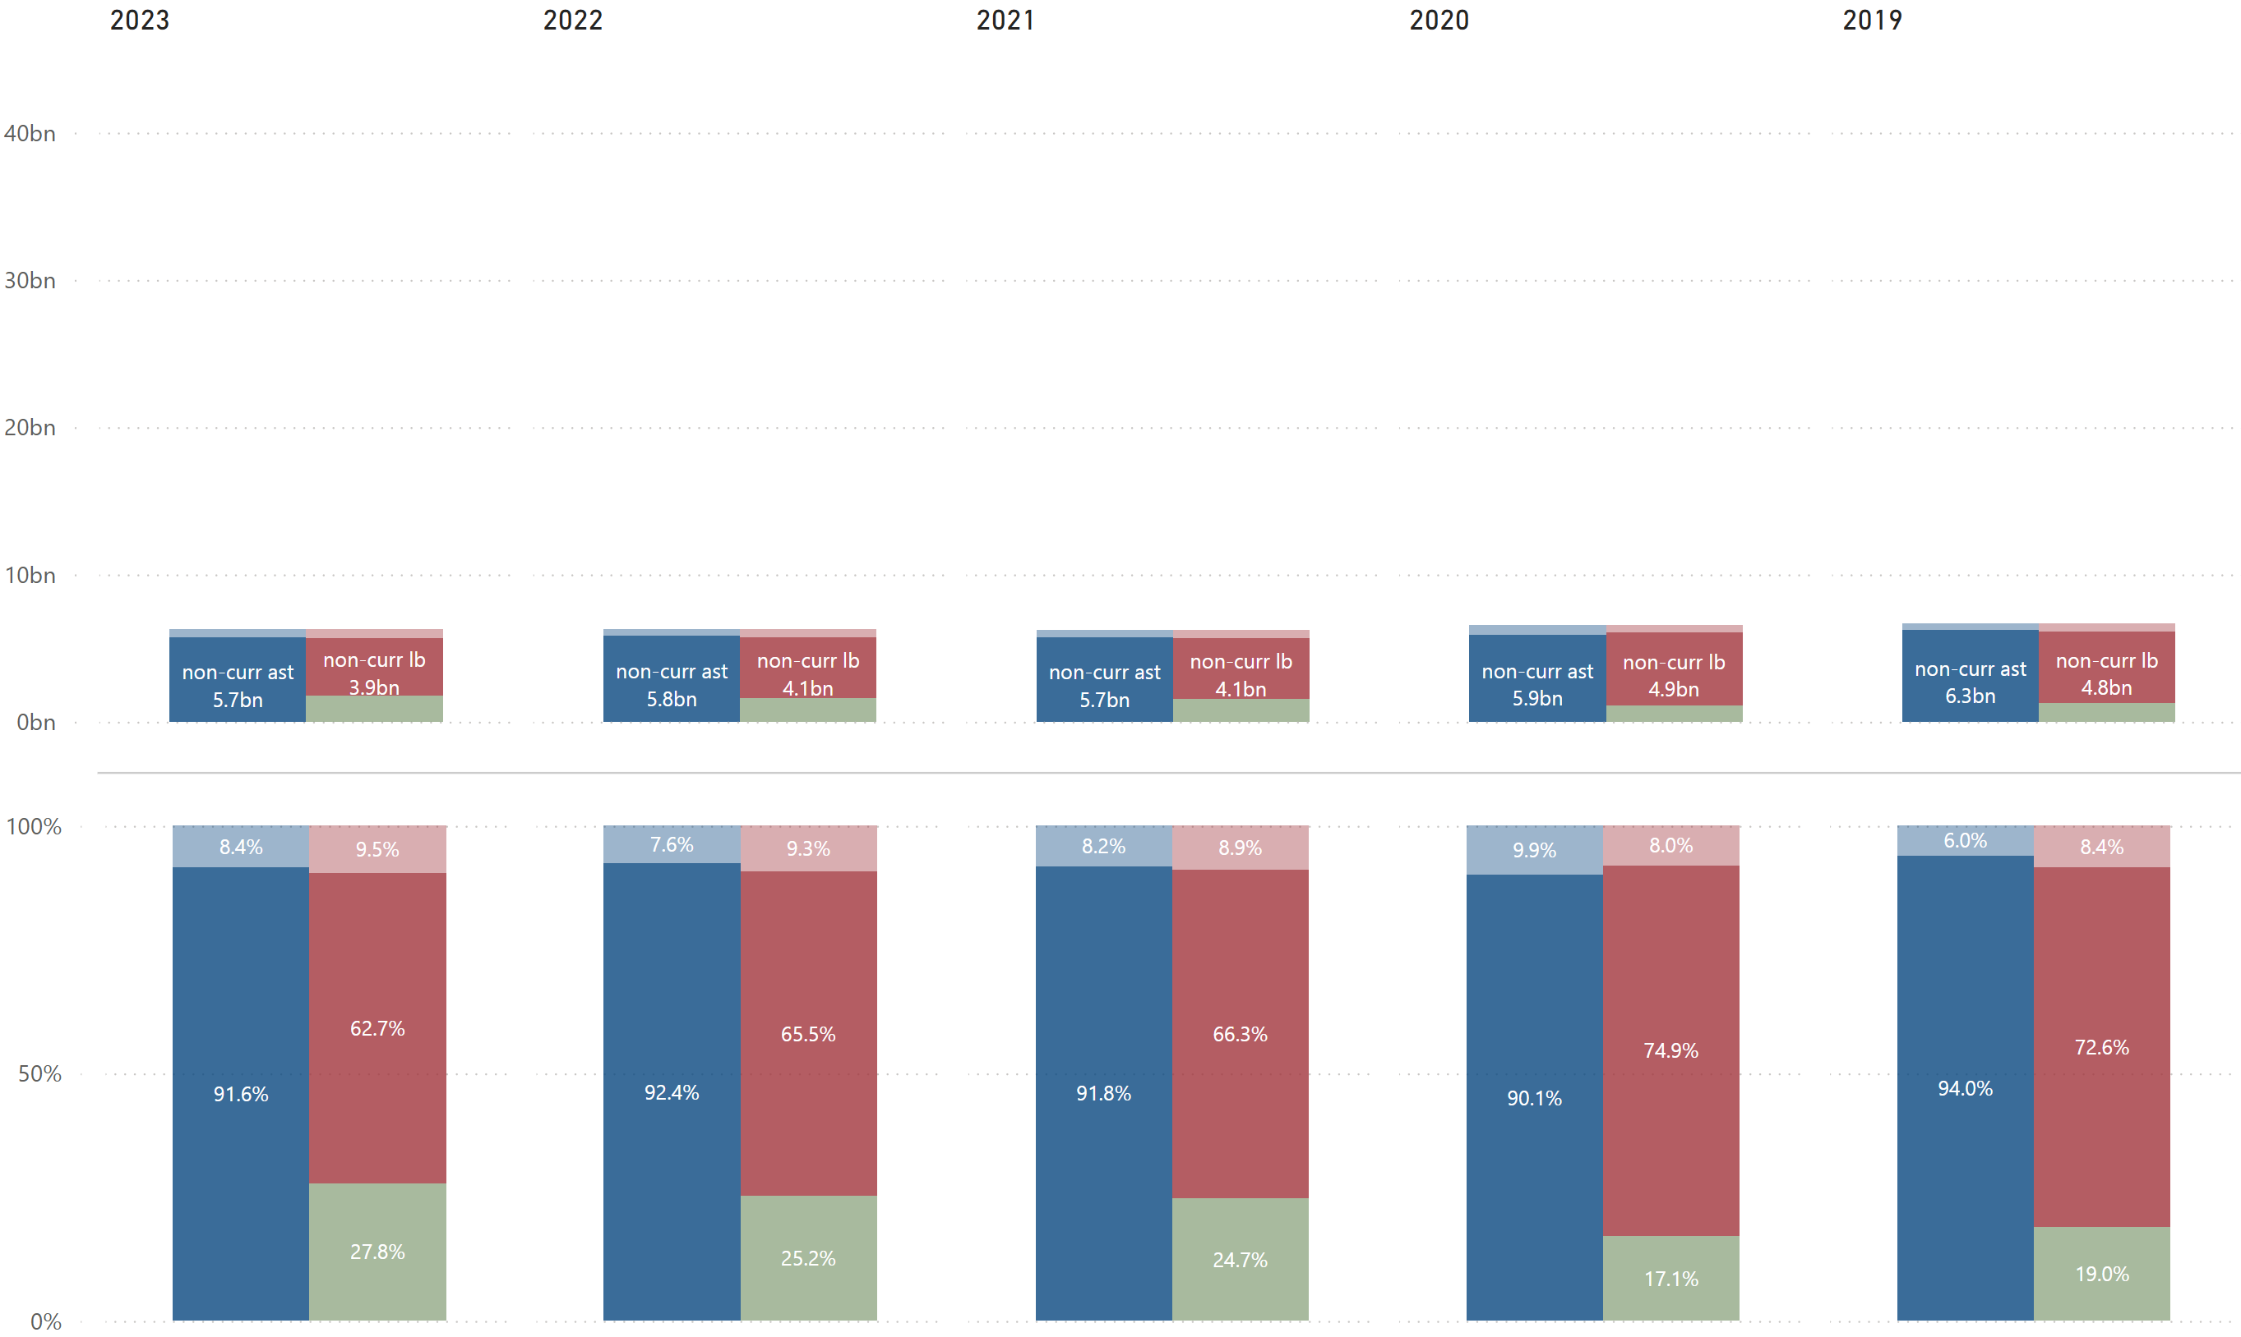

### P/L Chart

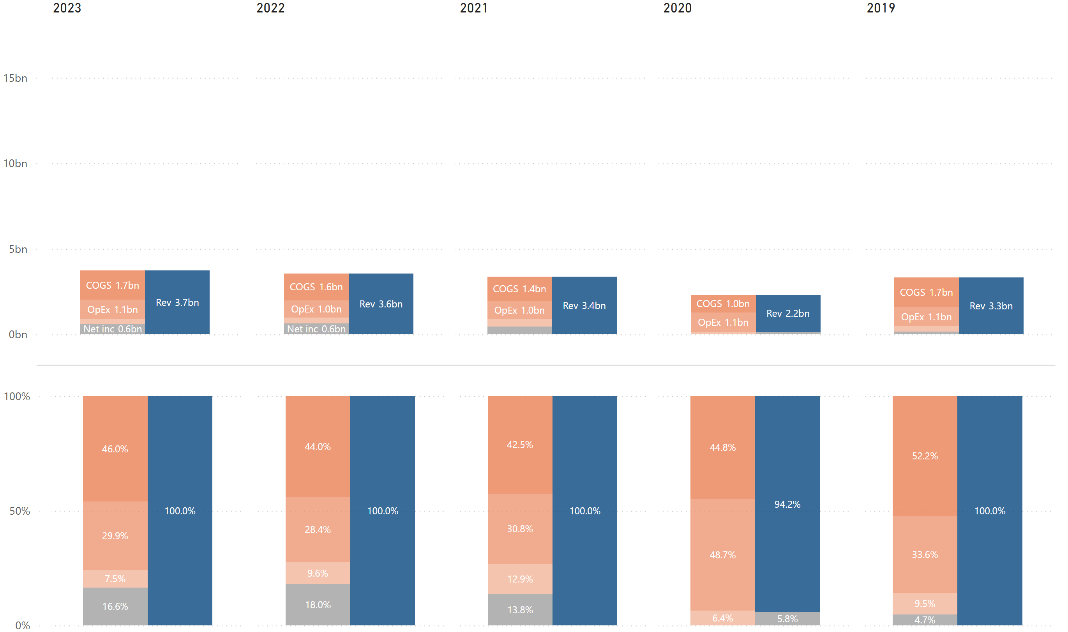

### Cash Flow Chart

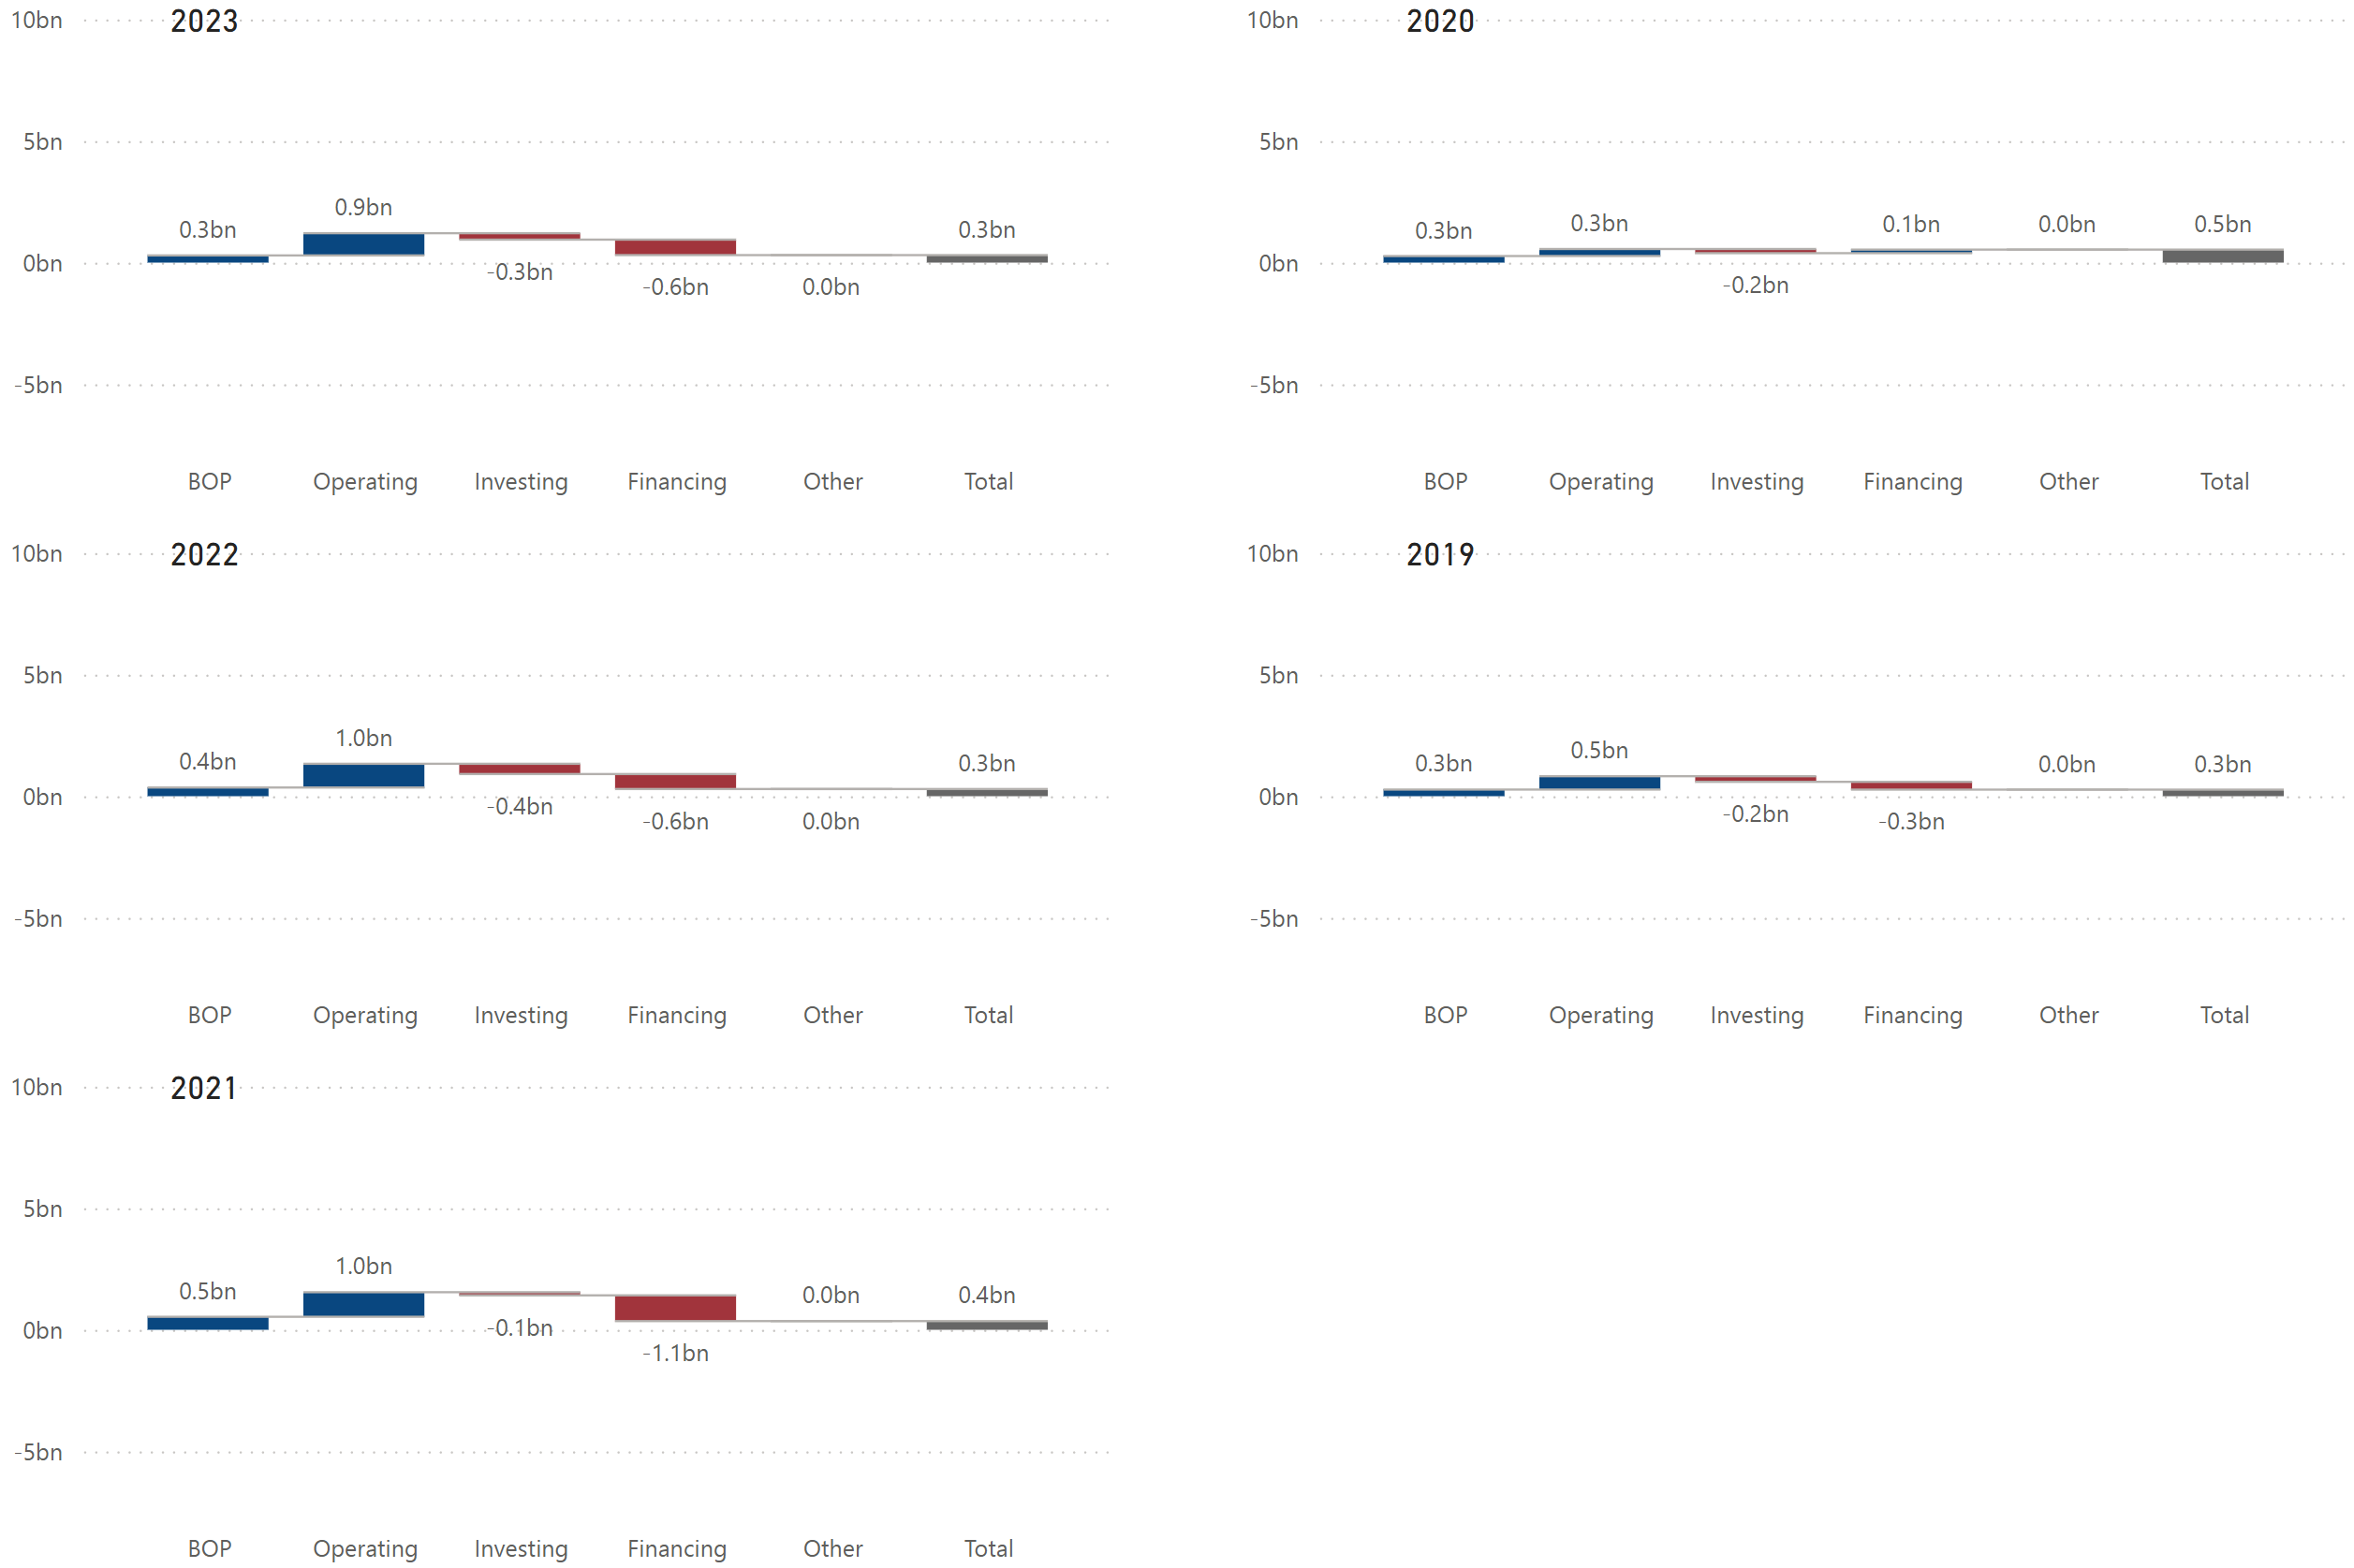

### Historical Financial Ratios



### Long-Term Debt (Most Recent Years)

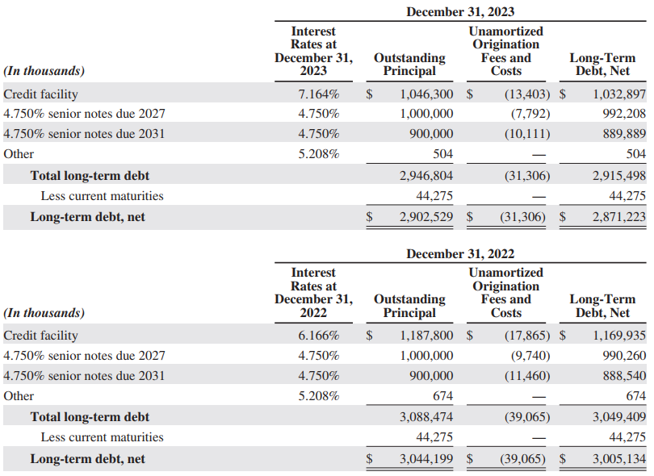

### Maturities of Long-Term Debt / Estimated Debt Service Requirements

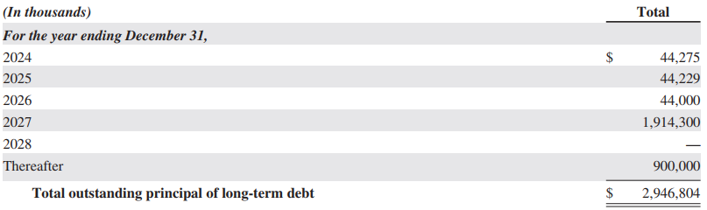

### Key Financial Insights

* (BS) ***The company’s equity % is much higher than its competitors***.
  + Most of the company’s equity comes from retained earnings. 7.6% points increase in 2021 was also driven by its retained earnings, which indicates the company’s high profitability.
* (BS) ***The company has had negative working capitals in last 5 years except 2020***.
  + The company mentions in its financial statement that it intentionally operates with minimal or negative levels of working capital to minimize borrowings and related interest costs. The company’s very low or negative working capital appears to be its strategic decision, reflecting its confidence that cash balances, available borrowing capacity, and cash flows from operating activities will be sufficient to meet its liquidity and future capital resource needs. In fact, the company’s cash conversion cycle in 2023 was -14 days, meaning it can generate cash very quickly due to high receivables and inventory turnover and low payable turnover.
* (PL) ***The company has very high profitability***.
  + The company’s profitability ratios improved a lot in 2021. According to its 2021 annual report, after re-openings properties post-COVID-19 pandemic, the company implemented a strategic shift in its operating model to focus on maximizing gaming revenues, streamlining its cost structure, targeting its marketing investments, and reducing lower margin offerings. This allowed the company to flow a higher percentage of its revenues to the bottom line. In fact, he company’s gross margin % for its main business segments (gaming, food & beverage, room) successfully improved in 2021, compared to previous years (refer to Boyd’s historical gross margin % by segment in the supplemental data section).
  + Compared to its competitors, the company has less gap between EBITDAR margin and EBIT margin. The company leases only 4 out of its 28 properties from third parties, resulting in lower rent expenses. Although owed properties incur depreciation expenses, the company appears to be effectively making profit from them. In fact, the company’s 5-year average fixed assets turnover and total assets turnover are the highest among its competitors, indicating high efficiency.
* (CF) ***The company has been successfully managing its cash flow at almost the same level as pre-COIVD-19. Over the last 5 years, the company spent as much cash on investing and financing activities as it generated from operating activities.***
  + The company’s investing activities mainly include capital expenditures.
  + The company has been managing its debt and servicing it with cash and refinancing. It also spent cash on both share repurchases and dividends over the last 5 years, except for 2021, where the company did not pay dividends and only repurchased shares, demonstrating its confidence in the ability to generate cash from its operations.
* (Debt) ***The company has a significantly higher amount of debt maturities in 2027 ($1.9 billion)***.
  + The company has been paying total of $1.7 billion, $2.1 billion, $1.8 billion, $1.4 billion, and $2.9 billion in 2023, 2022, 2021, 2020, and 2019, respectively, by efficiently refinancing and using its free cash flow while also paying dividends and repurchasing shares. Therefore, the company should have the capacity to service its higher debt maturities in 2027 with no issues.

## A red and white logoRed Rock Resorts (Station Casinos)

### Employees & Labor Relations

As of January 31, 2024, the company had approximately 9,385 employees, all of whom were employed in the United States.

### Business

Red Rock Resorts, Inc is a holding company that owns an indirect equity interest in and manages Station Casinos LLC through which the company conducts all of its operations. Station LLC is a gaming, development and management company established in 1976 that develops and operates strategically-located casino and entertainment properties. Station LLC owns and operates seven major gaming and entertainment facilities, including Durango Casino & Resort, and ten smaller casinos (three of which are 50% owned).

The company owns all of the outstanding voting interests in Station LLC and has an indirect equity interest in Station LLC through its ownership of limited liability interests in Station Holdco LLC, which owns all of the economic interests in Station LLC. At December 31, 2023, the company held 58% of the economic interests and 100% of the voting power in Station Holdco, subject to certain limited exceptions, and the company is designated as the sole managing member of both Station Holdco and Station LLC. The company controls and operates all of the business and affairs of Station Holdco and Station LLC. Other than tax-related assetsand liabilities, the company’s only assets are its equity interest in Station Holdco, its voting interest in Station LLC and a note receivable from Station LLC. The company has no operations outside of its management of Station Holdco and Station LLC.

The company’s consolidated financial statements reflect the consolidation of Station LLC and its consolidated subsidiaries and Station Holdco. The financial position and results of operations attributable to LLC Units the company does not own are reported separately as noncontrolling interest.

The company’s principal source of revenue and operating income is gaming, and its non-gaming offerings include restaurants, hotels and other entertainment amenities. Approximately 80% to 85% of its casino revenue is generated from slot play. The majority of its revenue is cash-based and as a result, fluctuations in the company’s revenues have a direct impact on its cash flows from operations.

### Organizational Structure

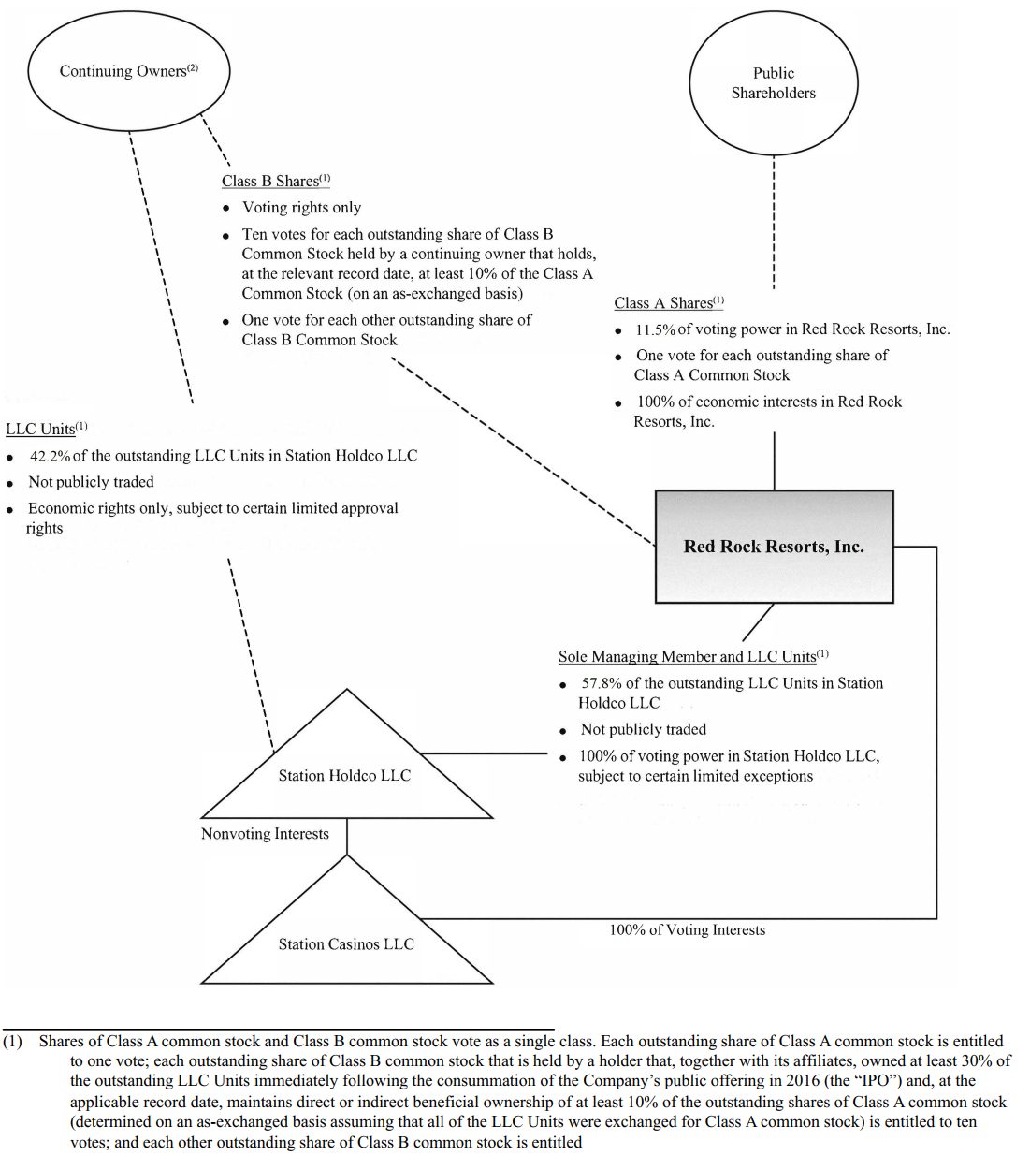

### Key Risk Factors Unique to Red Rock Resorts

* The company depends on the residents of the Las Vegas regional market and repeat visitors, which subjects the company to greater risks than a gaming company with more diverse operations.

### Properties (as of Dec. 31, 2023)

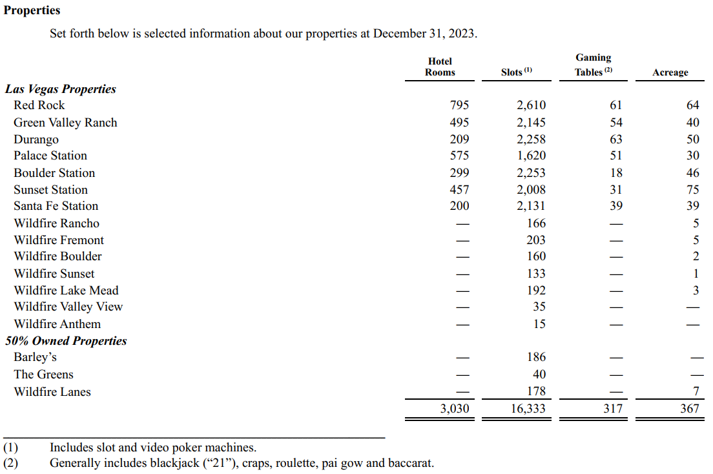

### Balance Sheet Chart

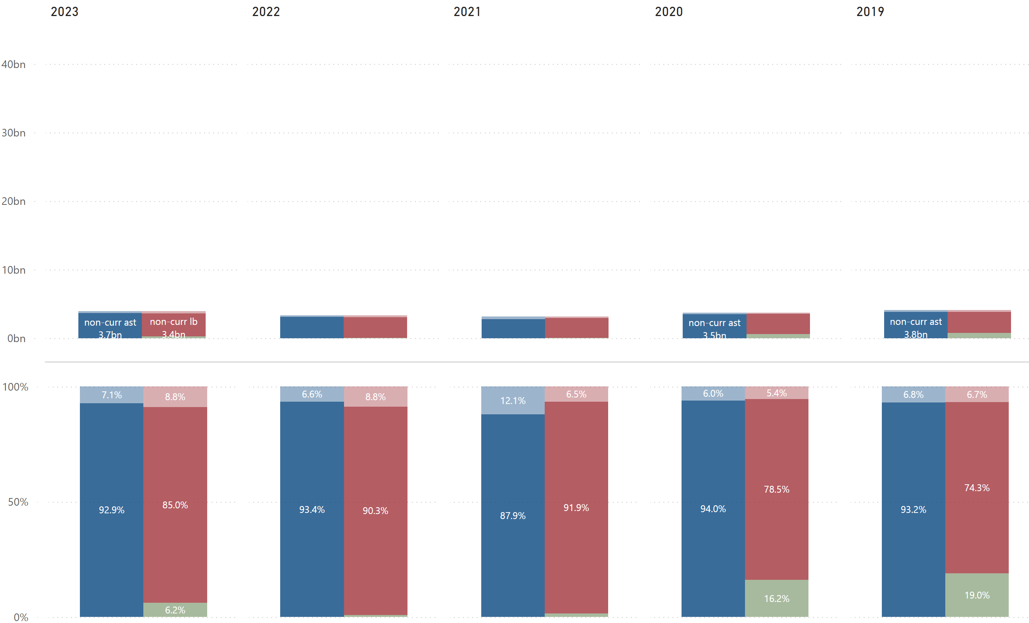

### P/L Chart

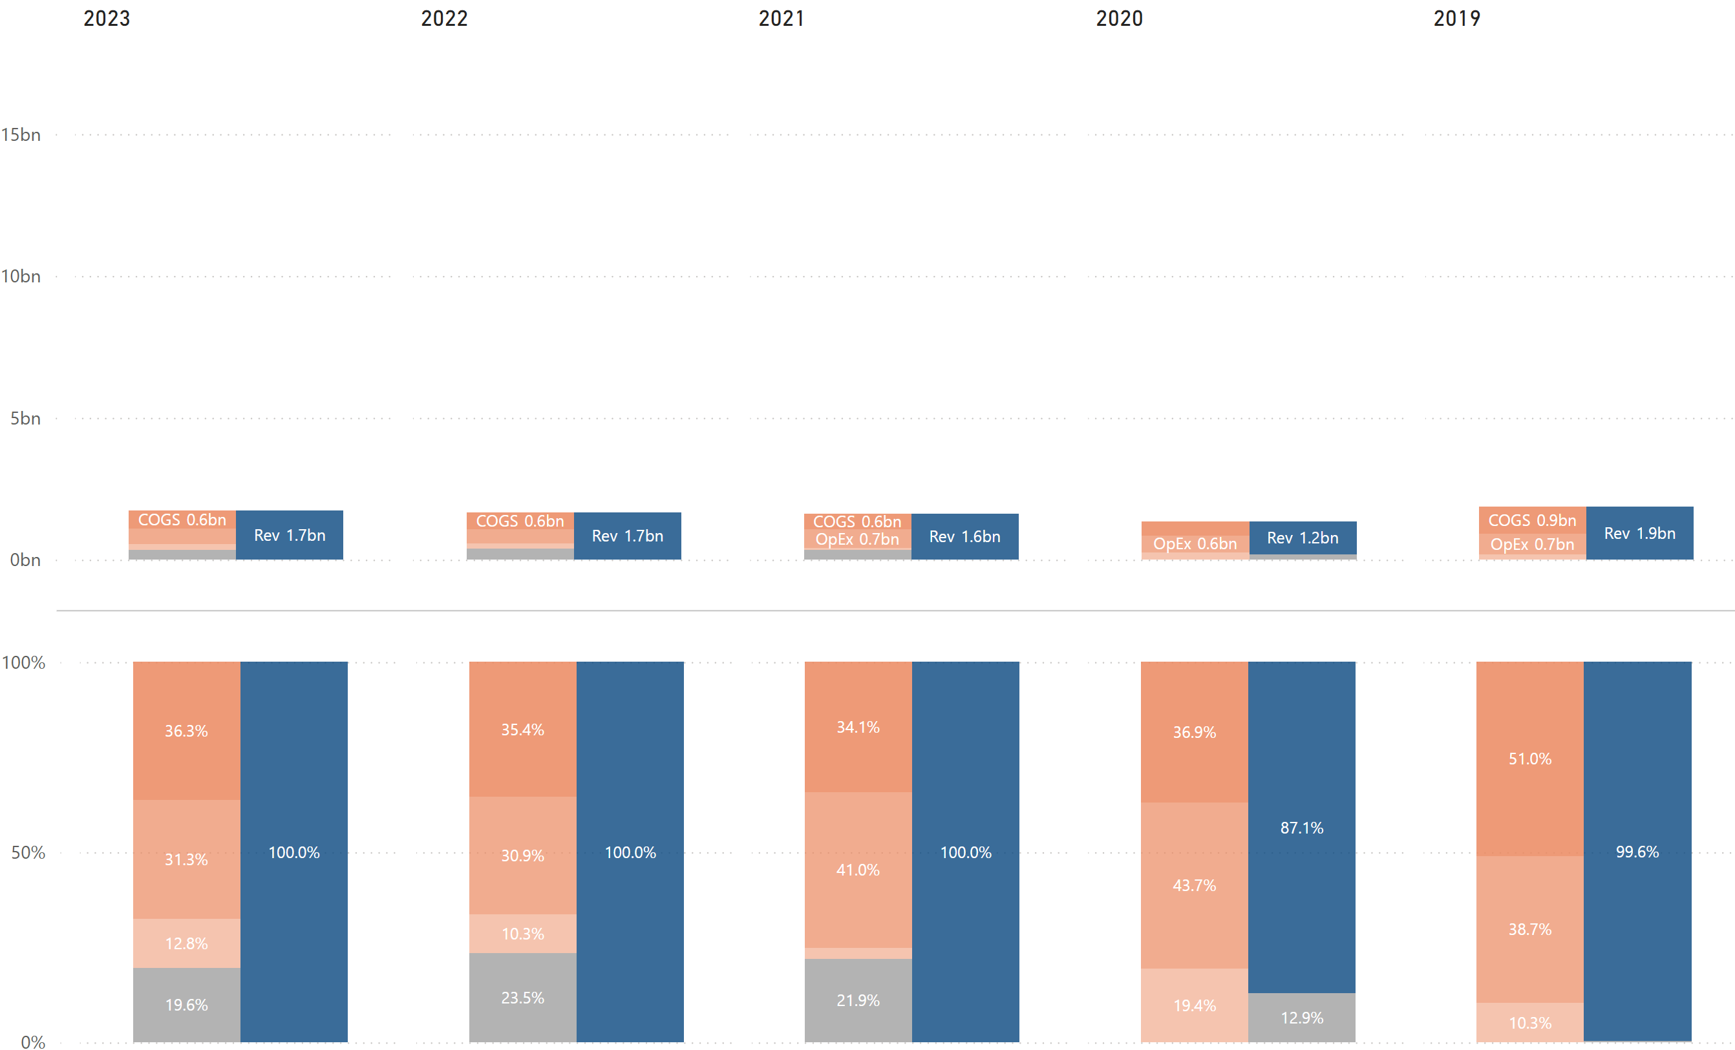

### Cash Flow Chart

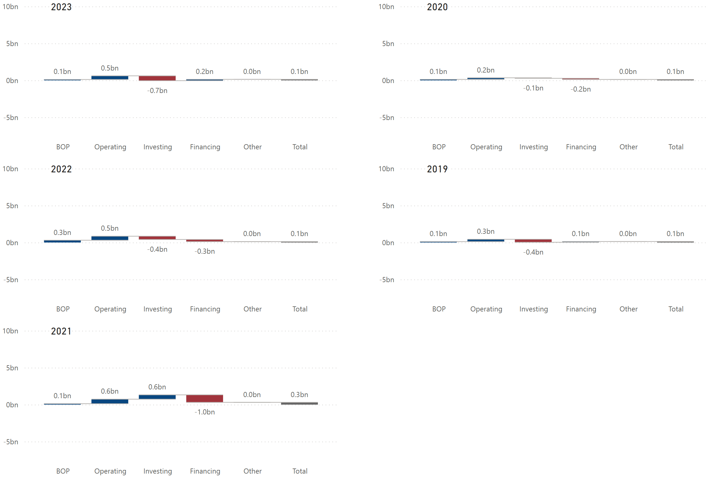

### Historical Financial Ratios



### Long-Term Debt (Most Recent Years)

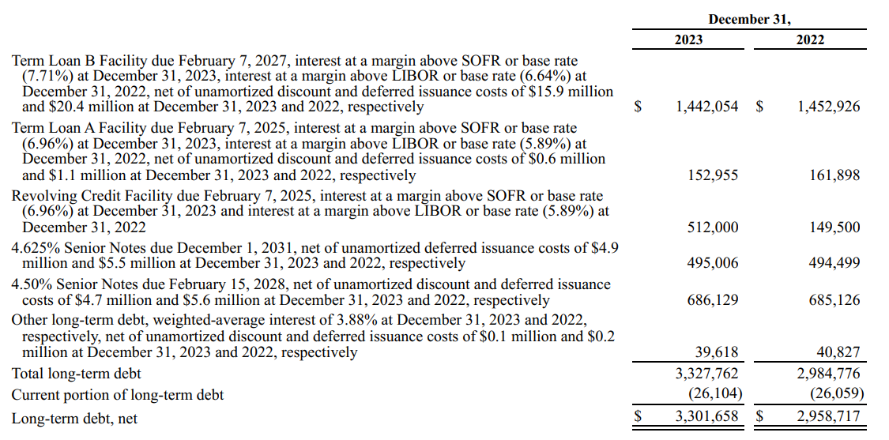

### Maturities of Long-Term Debt / Estimated Debt Service Requirements

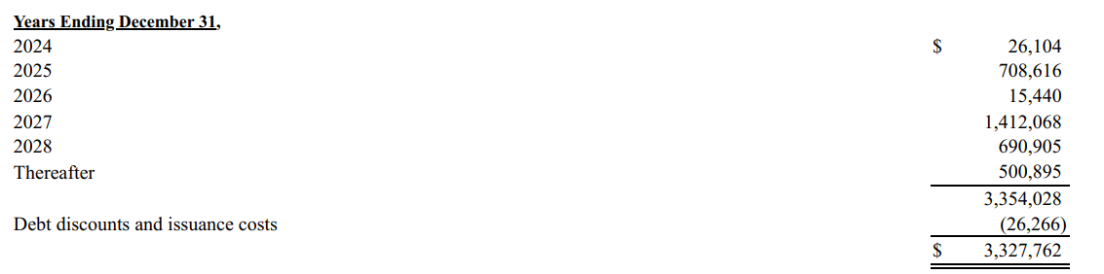

### Key Financial Insights

* (BS) ***The company’s equity % dropped significantly in 2021***. **It remained relatively flat in 2022 and slightly increased in 2023**.
  + The $555 million decrease in total equity in 2021 was primarily due to repurchases of common stock ($500 million), distributions to noncontrolling interest holders of Station Holdco ($237 million), and dividends declared ($205 million), partially offset by net income of $355 million (refer to Red Rock’s historical equity statement in the supplemental data section).
  + Total equity increased in 2023 as the company had lower distributions to noncontrolling interests and dividends declared, while generating as much revenues as in previous years (refer to Red Rock’s historical equity statement in the supplemental data section).
* (PL/Ratio) ***The company has a very low COGS %, leading to its high profitability.***
  + There are 2 possible reasons for this. One is that the company is more efficient in generating revenues, and the other is that the company pays less to its employees.
    - Rough calculations indicate that the company generates $183,707 per employee ($1.7 billion revenues / 9,385 employees), which is much lower than its competitors. The company might be less effective in terms of employee productivity.
    - The company’s fixed assets turnover is lower than the industry average and its total assets turnover is about the same as the industry average. This indicates that the company is not as efficient as its competitors in utilizing assets to generate revenues.
    - It appears that the company does not have official collective bargaining agreements at any of its properties, although it seems to be in the middle of these discussions. This gives the company more flexibility and control, as they do not have to negotiate with unions about wages, benefits, working conditions, etc.
    - Based on the factors above, the company’s low COGS % can be explained by less (or zero) costs related to unions and/or lower wages.
* (CF) ***In 2020, the company’s cash flows from operating, investing, and financing activities were +, -, -“ respectively***. ***In 2021, the company’s cash flows from operating, investing, and financing activities were “+, +, -“ respectively***. ***In 2022, the company’s cash flows from operating, investing, and financing activities were “+, -, -“ respectively***. ***In 2023, the company’s cash flows from operating, investing, and financing activities were “+, -, +“ respectively.***
  + Overall, the company steadily generates positive cash flows from operating activities and spends that cash on investing and financing activities. It appears that the company tries to keep its EOP cash balances around $100~$300 million.
  + In 2020, the company spent as much cash on investing and financing activities as it generated from operating activities, resulting in almost no change in its EOP cash balances.
  + In 2021, the company had positive cash flows from investing activities, primarily due to net proceeds from asset sales (Palms Las Vegas). The company also had large negative cash flows from financing activities, mainly due to repurchases of common stock and increase in distributions to noncontrolling interests and dividends paid (refer to Red Rock’s historical cash flow statement in the supplemental data section).
  + In 2022, the company had a large negative cash flows from investing activities, mainly due to a significant increase in capital expenditures (the Durango project) and acquisition of land held for development, partially offset by the sale of land parcels in Las Vegas and Henderson. The company’s negative cash flows from financing activities were primarily due to repurchases of common stock and increase in distributions to noncontrolling interests and dividends paid (refer to Red Rock’s historical cash flow statement in the supplemental data section).
  + In 2023, the company spent more on investing activities than the previous year, primarily due to an increase in capital expenditures (the Durango project). The company had positive cash flows from financing activities mainly due to an increase in net borrowings and a decrease in distributions to noncontrolling interests and dividends paid. Additionally, the company did not repurchase common stock this year (refer to Red Rock’s historical cash flow statement in the supplemental data section).
* (Ratio) ***The company’s financial leverage is significantly higher than the industry average.***
  + The company’s financial leverage has been higher since 2021, which was driven by a significant decrease in additional paid-in capital (refer to Red Rock’s historical balance sheet in the supplemental data section), due to repurchases of common stock, while the company’s liability structure has not changed much.
  + The company’s retained earnings turned negative in 2020, primarily due to its net loss, mainly as a result of the COVID-19 pandemic. However, it has been increasing due to an increase in net income (with some fluctuations caused by dividends and share repurchases). Total equity will likely increase as the company accumulates retained earnings, which will lower its financial leverage.

* (Ratio) ***The company’s ROE is significantly higher than the industry average***.
  + The company’s high ROE is driven by both a higher net profit margin and higher financial leverage (refer to DuPont analysis in the supplemental data section).
* (Debt) ***The company has much large amount of debt maturities in 2025, 2027, and 2028***.
  + While the company has strong revenue and operational performance, the current level of cash flows from operating activities are insufficient to cover the upcoming debt maturities. Therefore, the company will likely need to rely on debt refinancing.
  + The company’s working capital and free cash flow were both negative in 2023. However, this was due to the Durango project, which was completed in December 2023 upon its opening. If the casino performs well, it can grow revenue and cash flows, which would increase its free cash flow and help service its debt.

# Final Notes

**MGM Resorts International** demonstrates the most balanced and stable financial structure in the industry as of December 31, 2023. MGM’s higher ROE is driven by significant financial leverage, primarily resulting from 1) an increase in non-current liabilities, mainly due to higher lease liabilities and 2) a decrease in equity, primarily due to a series of share repurchases over recent years. The company also invests in BetMGM, an unconsolidated 50% owned venture, with a widely recognized brand, and is developing an integrated resort in Osaka, Japan. MGM’s current key investment focus appears to be on strengthening its position in the online sports betting and gaming market while advancing the Japan resort project.

Unlike MGM, **Caesars Entertainment** is grappling with a substantial interest burden. While its core operations generate decent profitability, it has not been sufficient to cover its interest expenses, resulting in net losses. Caesars operates the well-recognized Caesars Sportsbook and iGaming mobile apps. However, this heavy interest burden may limit its ability to invest in these rapidly growing markets. Without achieving the necessary scale to compete effectively, the company risks failing to realize the anticipated benefits from its investment.

**PENN Entertainment** primarily operates in regional markets, which may contribute to its low profitability. However, the company relies less on debt compared to its peers. PENN’s acquisition of theScore and its exclusive long-term strategic alliance with ESPN position it to leverage leading sports media brands in the United States (ESPN) and Canada (theScore) to grow in the online markets. This strategy could significantly expand PENN’s digital footprint and support efficient growth.

**Wynn Resorts**, with its smaller number of properties, experienced a slower recovery from the COVID-19 pandemic. The company adopts more conservative cash management practices than its competitors and boasts very high liquidity. Its online presence, however, lags behind its competitors, despite the existence of WynnBet. The company, along with Al Marjan Island and RAK Hospitality, is developing an integrated resort property Al Marjan Island in Ras Al Khaimah, United Arab Emirates. The resort is anticipated to be completed in 2027 and expected to have a substantial impact on Wynn’s financial performance.

**Boyd Gaming** appears to be another well-managed company alongside MGM. Post-pandemic, Boyd successfully implemented a strategic shift to increase profitability. It generates significant cash flow from operating activities while maintaining lower reliance on debt, which gives the company greater flexibility for investing and financing activities. Boyd’s higher ROE is driven by its high profitability. The company strategically targets customers from Hawaii and also has a strategic partnership with FanDuel Group, the nation’s leading sports-betting operator to pursue sports-betting opportunities across the country, both at its gaming properties and online.

**Red Rock Resorts** has the highest profitability among its competitors, which may be attributable to lower (or zero) union-related costs and/or lower wages. After a series of share repurchases, its financial leverage increased significantly in 2021, coinciding with a retained deficit. However, its retained earnings have since improved, and its financial leverage is expected to decline as the company accumulates net income in the coming years. Red Rock’s high ROE is driven by both high profitability and high financial leverage. The company just opened the Durango casino at the end of 2023, and if it performs well, it could further strengthen Red Rock’s financial structure.

# Supplemental Data

## MGM Resorts International

### Net Revenues & Adjusted EBITDAR by Segment



### Historical Operating Expenses



### KPIs by Segment

#### Las Vegas Strip



#### Regional



#### China



### Income from Unconsolidated Affiliates



### Historical Balance Sheet



Historical P/L Statement



### Historical Equity Statement

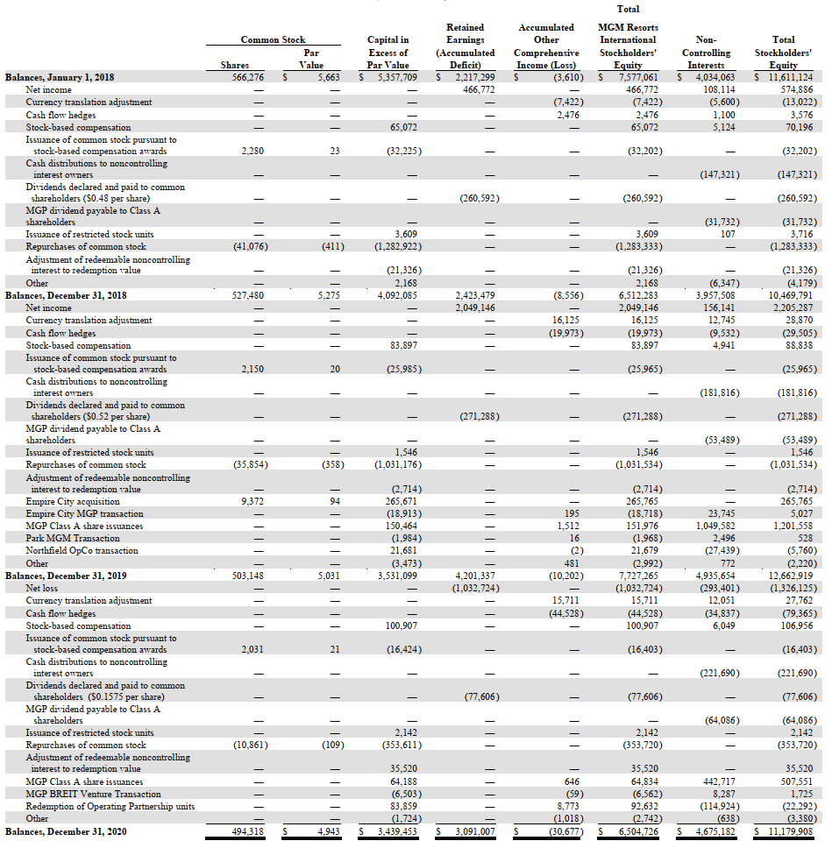

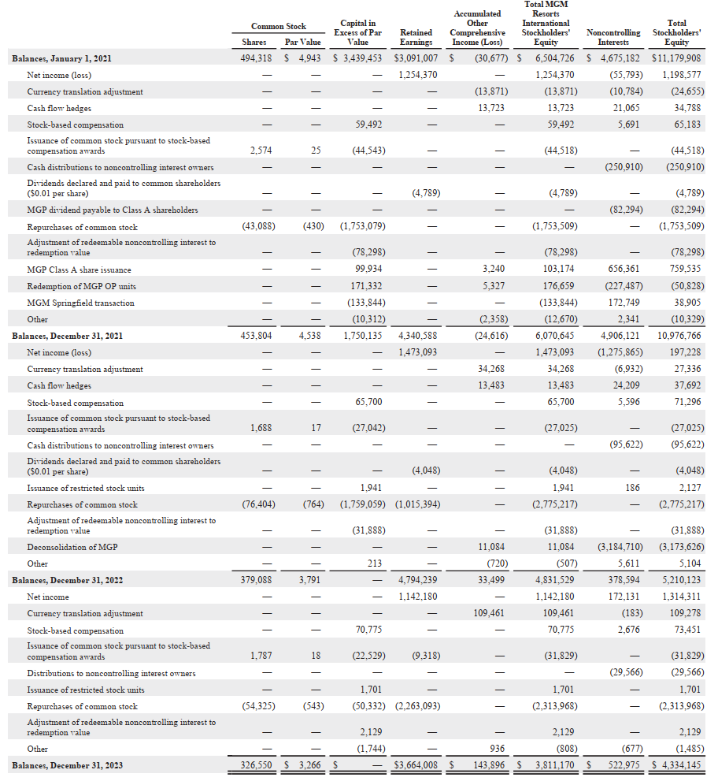

### Historical Cash Flow Statement



## Caesars Entertainment

### Net Revenues & Adjusted EBITDAR by Segment



Since Caesars utilizes EBITDA, instead of EBITDAR, the supplemental section is added to calculate Adjusted EBITDAR by adding back lease expenses.

No data for 2019 is available, as details by segment for the year were incomplete.

### Historical Operating Expenses



### KPIs by Segment

#### Las Vegas Strip



#### Regional



#### Digital



No data for 2019 is available, as details by segment for the year were incomplete.

### Historical Balance Sheet



### Historical P/L Statement



Historical Equity Statement

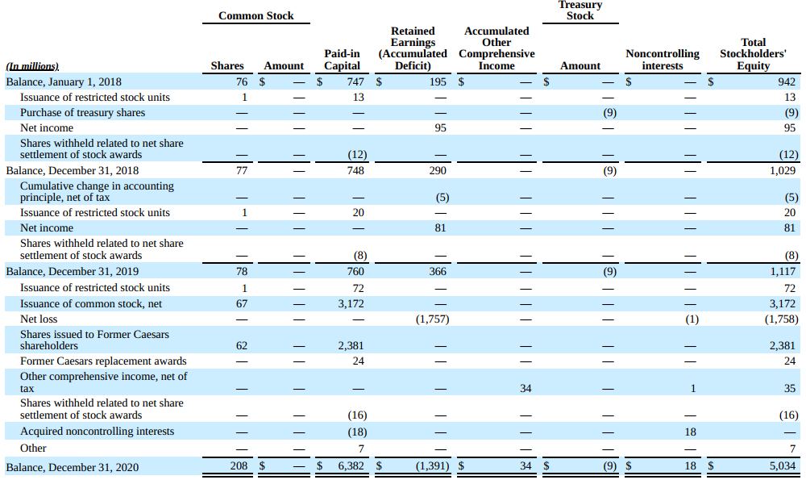

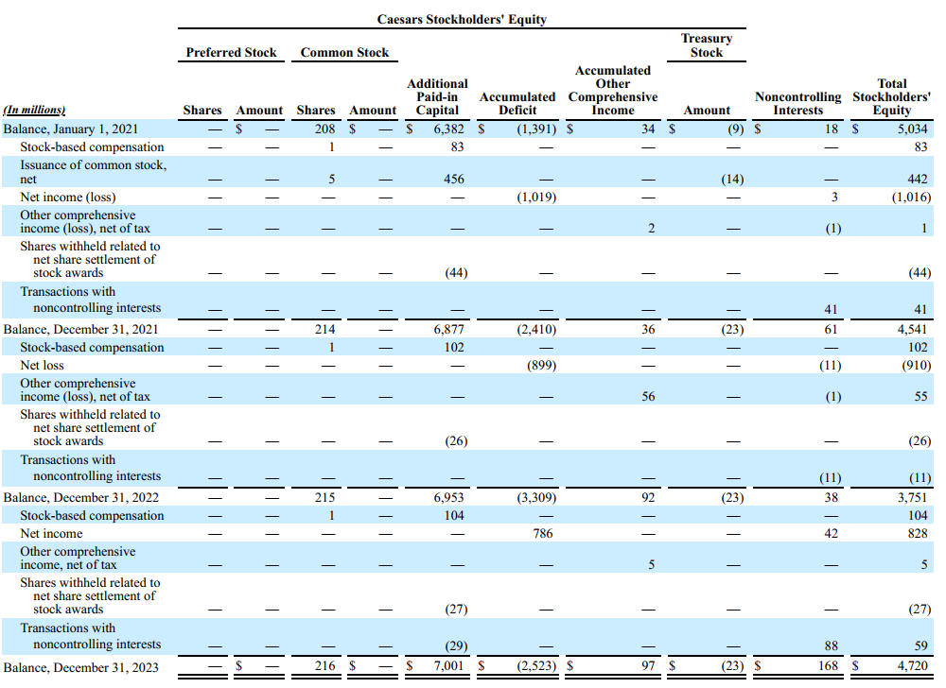

### Historical Cash Flow Statement



## PENN Entertainment

### Net Revenues & Adjusted EBITDAR by Segment



### Historical Operating Expenses



### KPIs



### Historical Balance Sheet



### Historical P/L Statement



Historical Equity Statement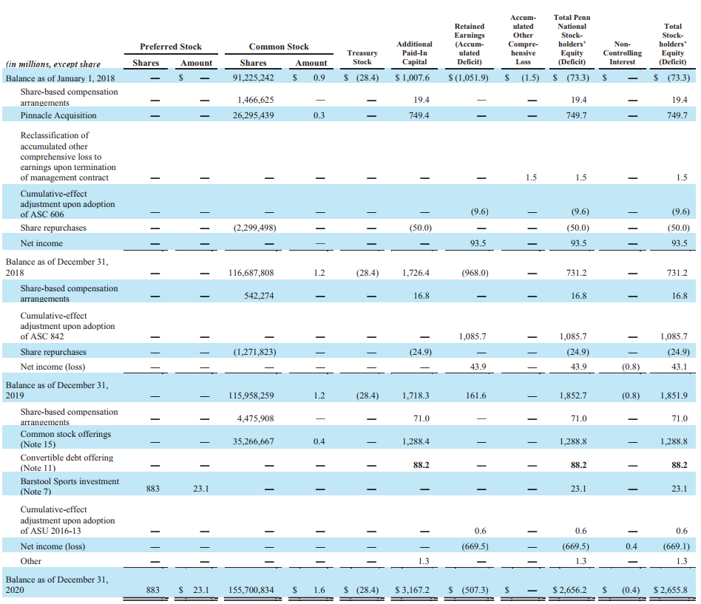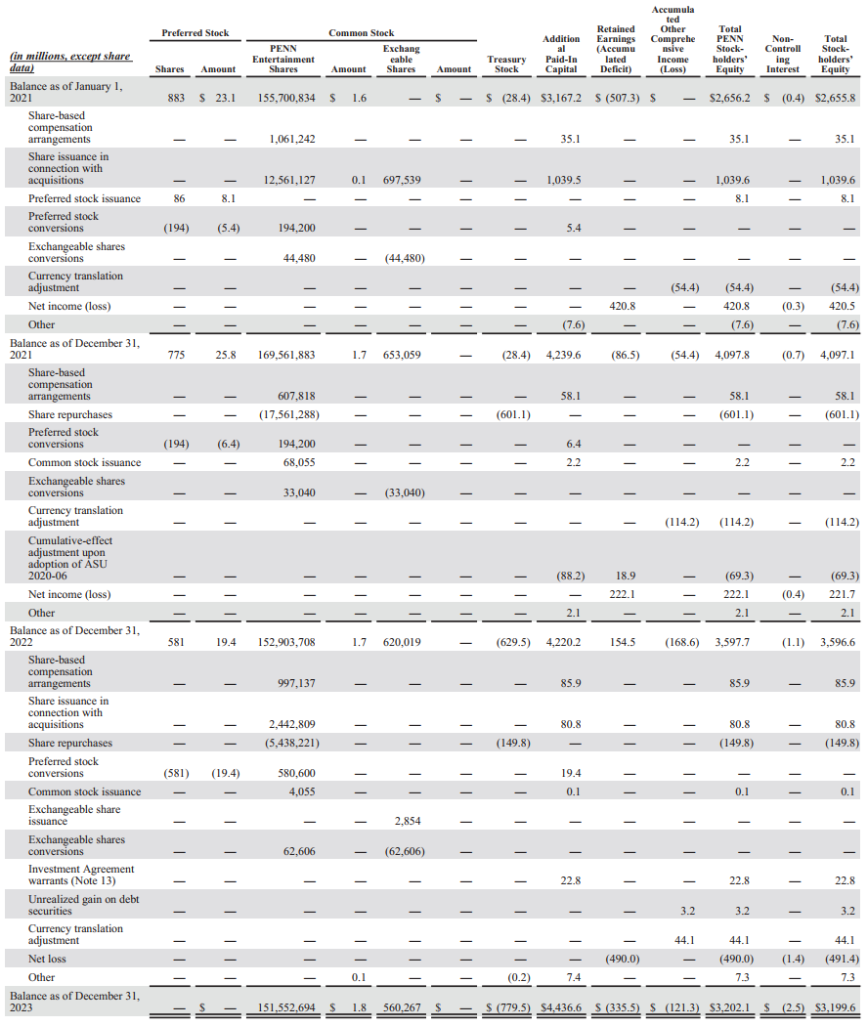

### Historical Cash Flow Statement



## Wynn Resorts

### Net Revenues & Adjusted EBITDAR by Segment



### Historical Operating Expenses



### KPIs by Segment

#### Wynn Palace



#### Wynn Macau



#### Las Vegas (Wynn / Encore)



#### Encore Boston Harbor



Historical Balance Sheet



Historical P/L Statement



Historical Equity Statement

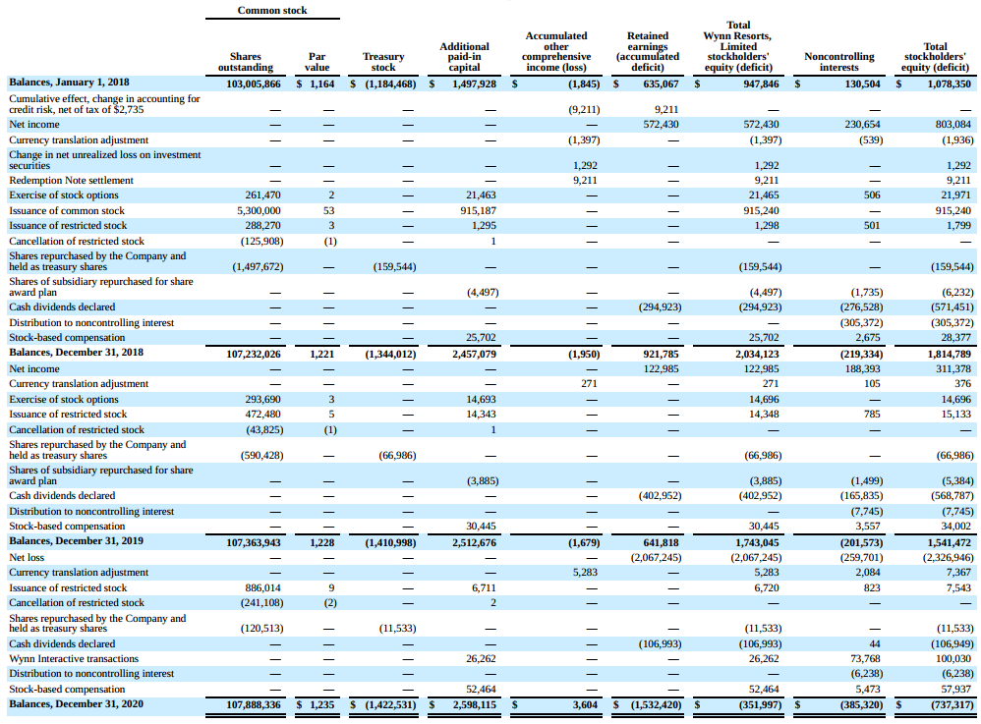

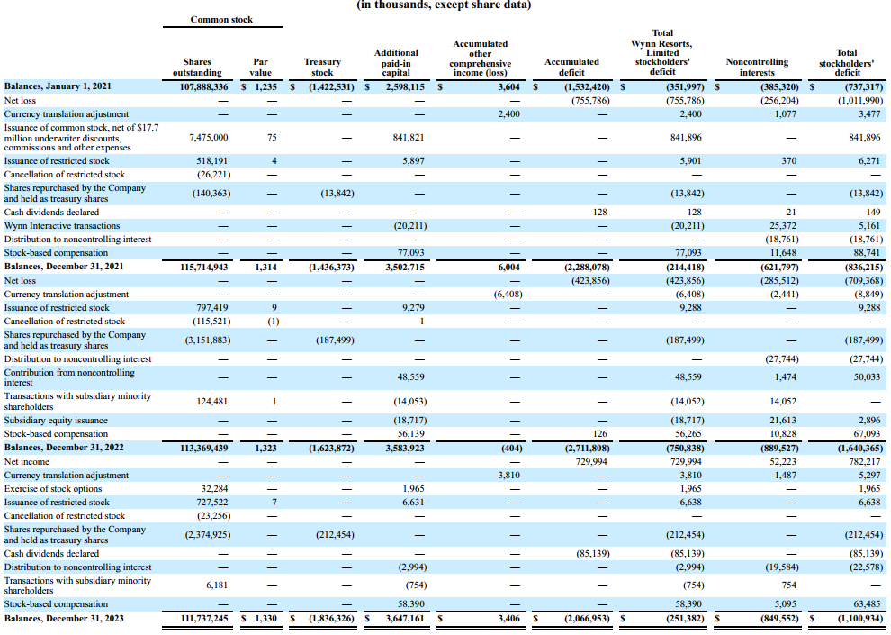

### Historical Cash Flow Statement



## Boyd Gaming

### Net Revenues & Adjusted EBITDAR by Segment



No breakdown for 2019 and 2020 as Las Vegas and regional segments include online and other revenues.

### Historical Operating Expenses



### Historical Gross Margin % by Segment



### KPIs by Segment

Details on gaming and hotel KPIs were not provided.

### Historical Balance Sheet



### Historical P/L Statement



Historical Equity Statement 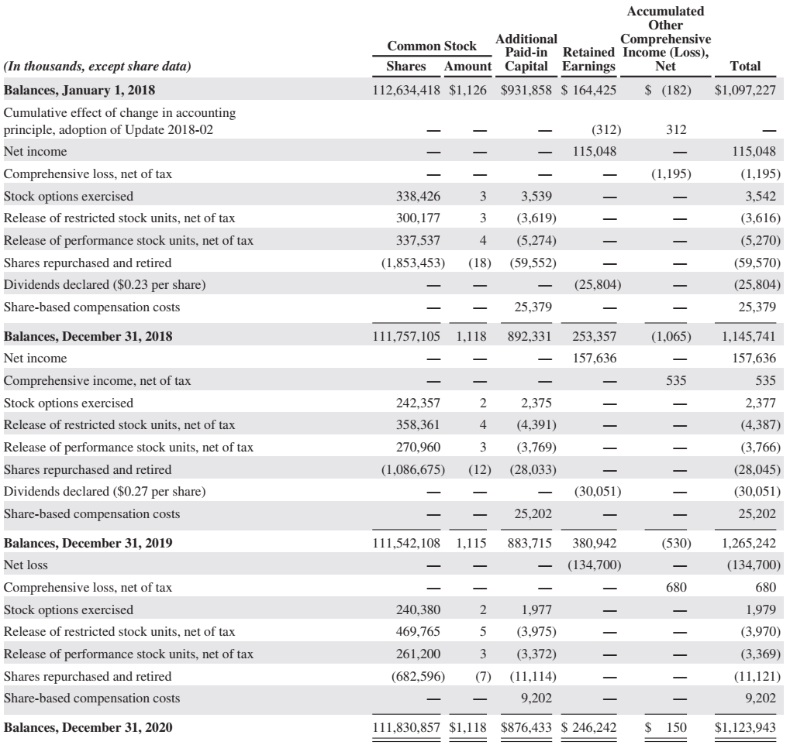 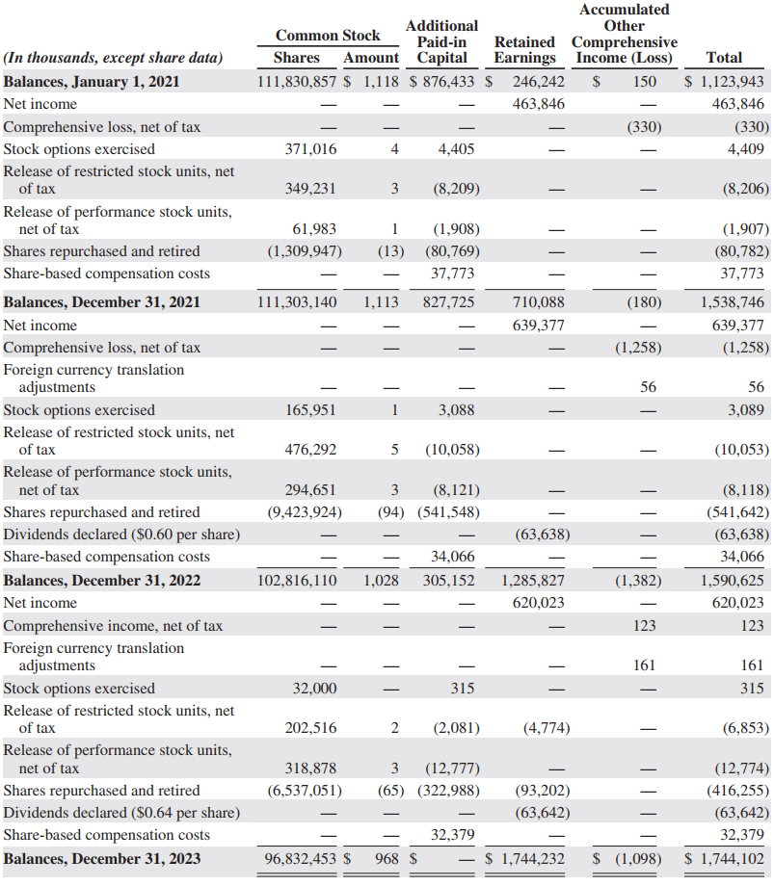

### Historical Cash Flow Statement



## Red Rock Resorts

### Net Revenues & Adjusted EBITDA by Segment



### Historical Operating Expenses



### Historical Gross Margin % by Segment



### KPIs by Segment

Details on gaming and hotel KPIs were not provided.

### Historical Balance Sheet



### Historical P/L Statement



Historical Equity Statement

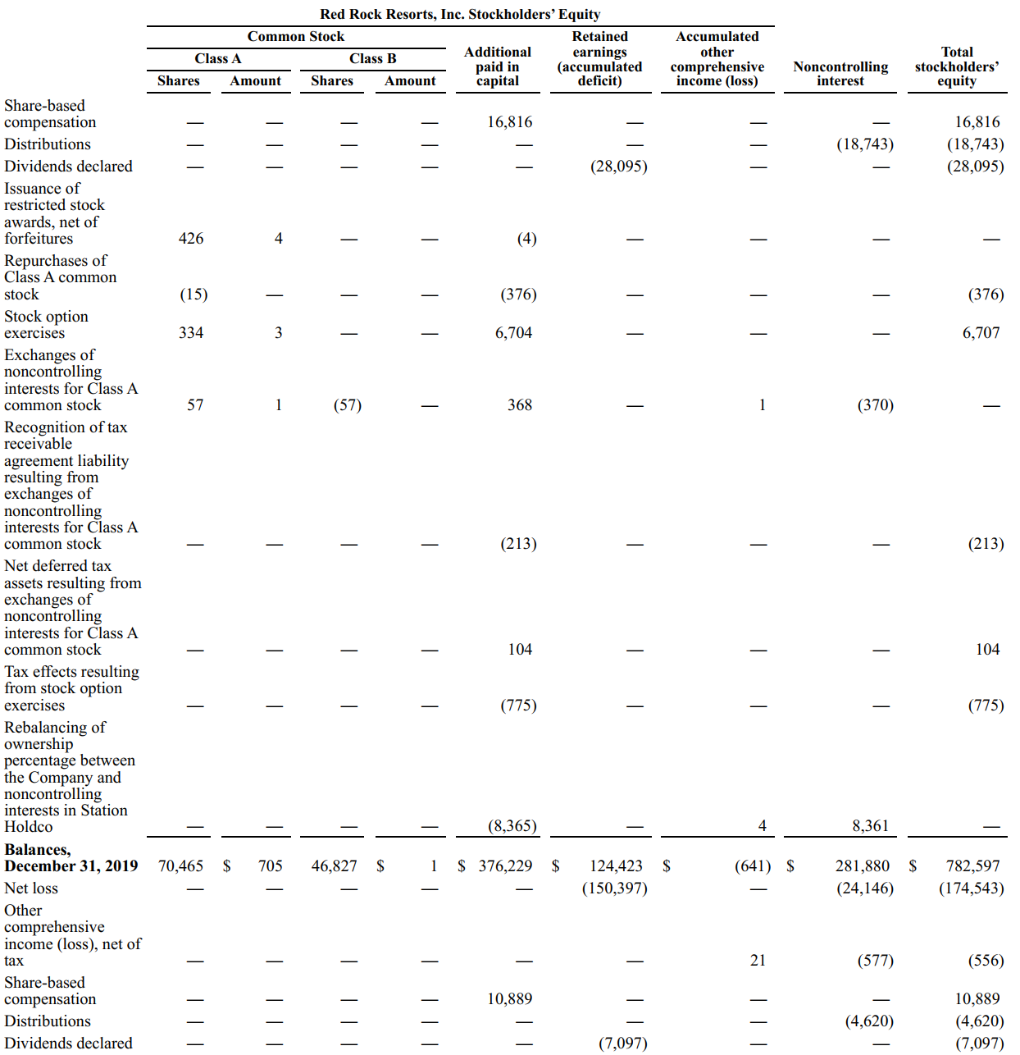 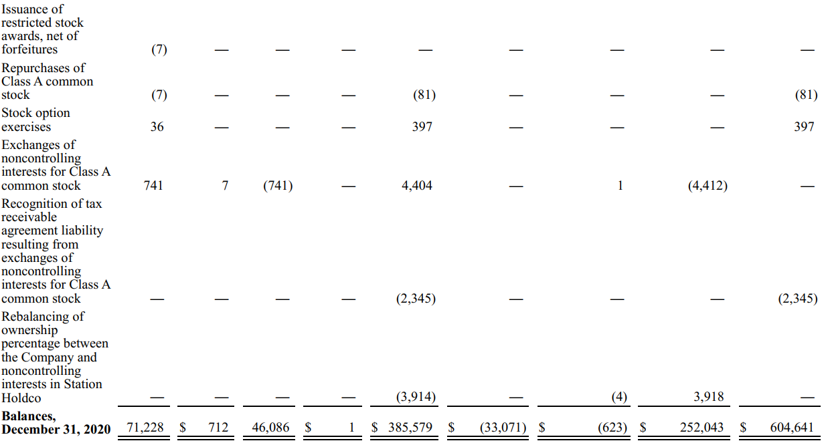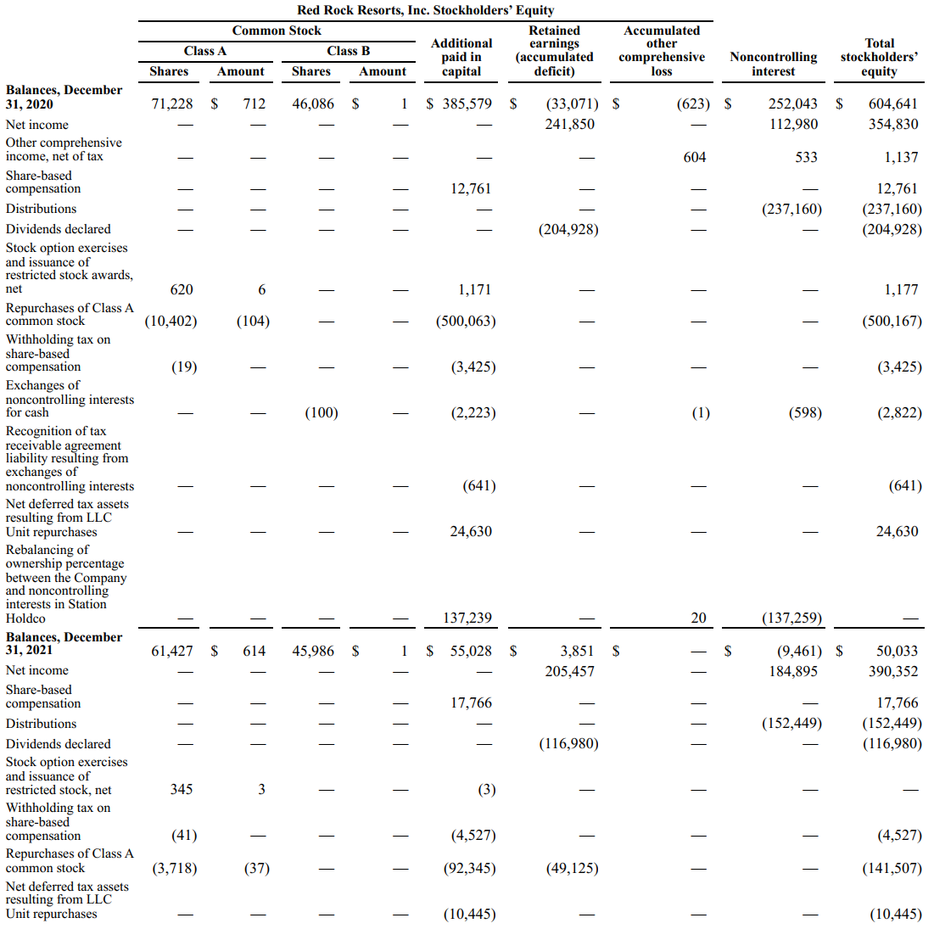 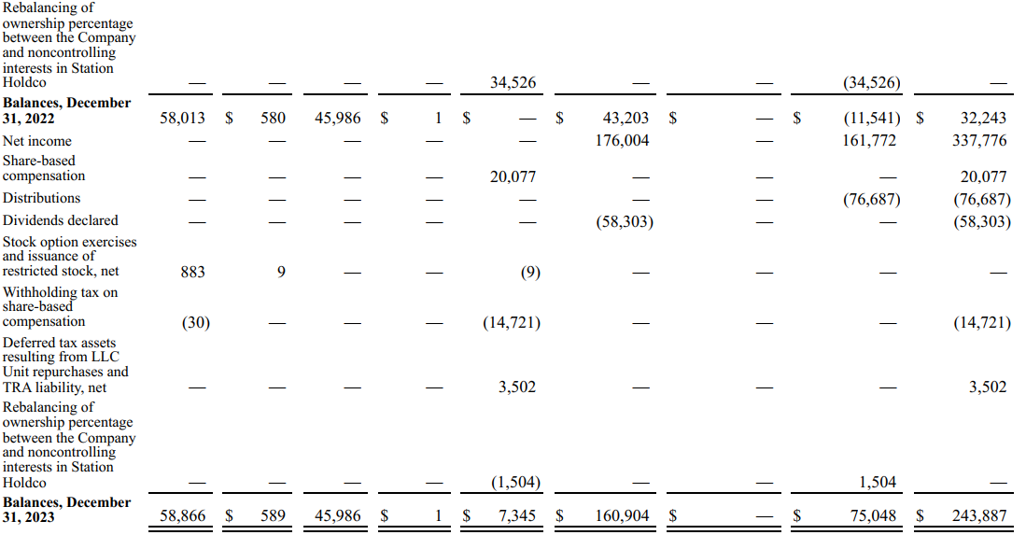

### Historical Cash Flow Statement



## DuPont Analysis (2023)

DuPont Analysis is a financial performance framework that helps break down a company’s ROE into 6 key components. This analysis provides insights into the drivers of a company’s financial performance, helping stakeholders understand how each factor contributes to the overall return.

### MGM Resorts International



### Caesars Entertainment



### PENN Entertainment



### Wynn Resorts



### Boyd Gaming



### Red Rock Resorts (Station Casinos)



## Financial Ratios Formula

### Activity Ratios

#### Receivables Turnover

Meaning: The efficiency of a company in collecting its receivables  
Formula: Revenue / Average Receivables

#### DSO

Meaning: The average number of days a company takes to collect its receivables from clients  
Formula: 365 / Receivables Turnover

#### Inventory Turnover

Meaning: The efficiency of a company in terms of inventory management  
Formula: COGS / Average Inventory

#### DIO

Meaning: The average inventory processing period  
Formula: 365 / Inventory Turnover

#### Payables Turnover

Meaning: The efficiency of a company in allowing its credit to suppliers  
Formula: Purchases / Average Payables

#### DPO

Meaning: The average number of days a company takes to pay its suppliers  
Formula: 365 / Payables Turnover

#### Cash Conversion Cycle

Meaning: The number of days a company takes to convert its investments in inventory and other resources into cash flows from sales

Formula: DSO + DIO - DPO

#### Fixed Assets Turnover

Meaning: The efficiency of a company in utilizing its fixed assets to generate revenue  
Formula: Revenue / Average Fixed Assets

#### Working Capital Turnover

Meaning: The efficiency of a company in managing its working capital (current assets – current liabilities)  
Formula: Revenue / Average Working Capital

#### Total Assets Turnover

Meaning: The efficiency of a company in utilizing its total assets to generate revenue  
Formula: Revenue / Average Total Assets

#### Equity Turnover

Meaning: The efficiency of a company in utilizing equity to generate revenue  
Formula: Revenue / Average Total Equity

### Liquidity Ratios

#### Current Ratio

Meaning: The ability of a company to meet current liabilities (with total current assets)  
Formula: Current Assets / Current Liabilities

#### Quick Ratio

Meaning: The ability of a company to meet current liabilities (with total current assets, excluding inventory and prepaid expenses)

Formula: (Total Current Assets – Inventory – Prepaid Expenses) / Current Liabilities

#### Cash Ratio

Meaning: The ability of a company to meet current liabilities (with cash only)  
Formula: Cash / Current Liabilities

#### Defensive Interval

Meaning: The number of days a company can cover its average daily expenses with the use of current liquid assets only

Formula: (Total Current Assets – Inventory – Prepaid Expenses) / Average Daily Expenditure

### Solvency Ratios

#### Debt-to-Equity

Meaning: Debt as a percentage of total equity  
Formula: Total Debt / Total Equity

#### Debt-to-Capital

Meaning: Debt as a percentage of total capital  
Formula: Total Debt / (Total Debt + Total Equity)

#### Debt-to-Assets

Meaning: Debt as a percentage of total assets  
Formula: Total Debt / Total Assets

#### Financial Leverage

Meaning: An indicator of a company’s debt financing usage  
Formula: Average Total Assets / Average Total Equity

#### Interest Coverage

Meaning: The ability of a company to cover its interest expenses  
Formula: EBIT (Operating Income) / Interest Payments

### Profitability Ratios

#### Gross Profit Margin

Meaning: Gross profitability as a percentage of total revenue  
Formula: (Revenue – COGS) / Revenue

#### Operating Profit Margin

Meaning: Operating profitability (before interest and tax) as a percentage of total revenue  
Formula: Operating Income (EBIT) / Revenue

#### Pre-Tax Profit Margin

Meaning: Operating profitability (before tax) as a percentage of total revenue  
Formula: EBT / Revenue

#### Net Profit Margin

Meaning: Net profitability as a percentage of total revenue  
Formula: Net Income / Revenue

#### ROA (Return on Assets)

Meaning: Net profitability (excluding interest and tax) as a percentage of total invested funds  
Formula: Net Income / Average Total Assets

#### Operating ROA

Meaning: Net profitability (including interest and tax) as a percentage of total invested funds  
Formula: Operating Income (EBIT) / Average Total Assets

#### ROC (Return on Total Capital)

Meaning: Operating profitability as a percentage of total capital  
Formula: Operating Income (EBIT) / Average Total Capital

#### ROE (Return on Equity)

Meaning: Net profitability as a percentage of total equity  
Formula: Net Income / Average Equity

### Valuation Ratios

#### EPS (Earnings Per Share)

Meaning: Income earned per 1 common share outstanding

Data is obtained from each company’s financial statement.

PE Ratio  
Meaning: The price that investors are willing to pay per $1 of earnings

Data is obtained from Macrotrends.